**Abstract -**

In mechanical power transmission system, gears plays vital role in automobile industries. Gear is a machine element, used to transmit motion and power from one shaft to another shaft by means of direct contact. The motion is transmitted by engagement of teeth. Gears are usually subjected to fluctuating loads.

This paper analysis the stress distribution and weight reduction developed in the gears. While designing the gear it is very important to analyze the stresses for safety operation, and weight reduction of gear is also one of the design criteria. Spur gear is the most basic gear used, where the power transmission is required in between the parallel shaft. Spur gears are generally fails by contact (or) bending failure.

In this project, the spur gear is modeled in “CATIA” software and imported to “ANSYS” for thermal, static analysis and dynamic analysis. The Static analysis is performed to determine the deformation. The results were validated with theoretical calculations by Lewis equation. Analysis is done by considering different materials for gears like **silicon carbide, structural steel, titanium** and results are compared.

**Key Words:** Spur Gear, CATIA, ANSYS Workbench, silicon carbide, structural steel, titanium, static analysis and dynamic analysis.

**CHAPTER – 1**

**GEARS**

**1. Introduction**:

**1.1Gear**

Gears are the most common means of transmitting power in the modern mechanical engineering world. They vary from a tiny size used in watches to the large gears used in lifting mechanisms and speed reducers. They form vital elements of main and ancillary mechanisms in many machines such as automobiles, tractors, metal cutting machine tools etc. Toothed gears are used to change the speed and power ratio as well as direction between input and output.

Gearing is one of the most critical components in a mechanical power transmission system, and in most industrial rotating machinery. It is possible that gears will predominate as the most effective means of transmitting power in future machines due to their high degree of reliability and compactness. In addition, the rapid shift in the industry from heavy industries such as shipbuilding to industries such as automobile manufacture and office automation tools will necessitate a refined application of gear technology. A gearbox as usually used in the transmission system is also called a speed reducer, gear head, gear reducer etc., which consists of a set of gears, shafts and bearings that are factory mounted in an enclosed lubricated housing. Speed reducers are available in a broad range of sizes, capacities and speed ratios. Their job is to convert the input provided by a prime mover (usually an electric motor) into an output with lower speed and correspondingly higher torque.

Gears are toothed members which transmit power/ motion between two shafts by meshing without any slip. Hence, gear drives are also called positive drives. In any pair of gears, the smaller one is called pinion and the larger one is called gear immaterial of which is driving the other. When pinion is the driver, it results in step down drive in which the output speed decreases and the torque increases. On the other hand, when the gear is the driver, it results in step up drive in which the output speed increases and the torque decreases. The increasing demand for quiet power transmission in machines, vehicles, elevators and generators, has created a growing demand for a more precise analysis of the characteristics of gear systems.

**1.2 Types of gears:**

1. Spur Gear
2. Helical Gear
3. Gear Rack
4. Bevel Gear
5. Spiral Bevel Gear
6. Screw Gear
7. Miter Gear
8. Worm Gear
9. 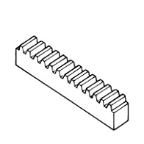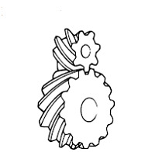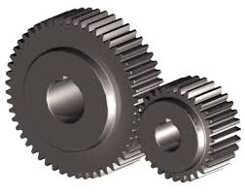Internal Gear

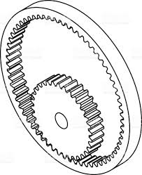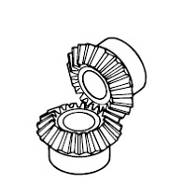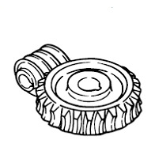 Spur Gear Helical Gear Gear Rack

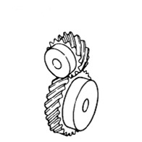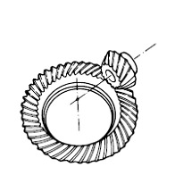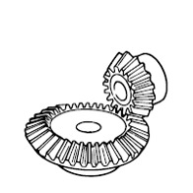Bevel Gear Spiral Bevel Gear Screw Gear

Miter Gear Worm Gear Internal Gear

Fig no 1.2. Types of Gears

**1. Spur Gear**

The spur gear is simplest type of gear manufactured and generally used for transmission of rotary motion between parallel shafts. The spur gear is the first choice option for gears except when high speeds, loads and ratios direct towards other options. Other gear types may also be preferred to provide more silent low-vibration operation.

**2. Helical gear:**

Quiet and able to transmit larger torque than spur gears. Cylindrical gears with spiral shaped tooth trace.

1. **Gear Rack:**

Changes rotary motion to linear motion. A set consisting of rectangular or circular rod shaped gear with mating small gear.

1. **Bevel Gear:**

Cone shaped gears used in intersecting shaft applications. There are also bevel gears with spiral shaped tooth trace called spiral bevel gears.

1. **Spiral Bevel gear:**

Cone shaped gears used in intersecting shaft applications. There are also bevel gears with straight shaped tooth trace called straight bevel gears.

1. **Screw Gear:**

Used in offset shaft application. Shape wise, they are the same as helical gears.

1. **Miter Gear:**

Type of bevel gears in which the pair is made of same number of teeth and used where speed reduction or increase is not needed.

1. **Worm Gear:**

Used when a large speed reduction is needed. Worm and worm gear set. Normally, different materials are used for worm and worm gear.

1. **Internal Gear:**

Gear teeth are cut on the inside surface of hollow cylindrical forms and used in planetary gear systems. The gear teeth are cut using gear shaper machines.

**1.3 OVERVIEW OF SPUR GEAR**

Spur gears are the most common type of gears. They have straight teeth, and are mounted on parallel shafts. Sometimes, many spur gears are used at once to create very large gear reductions. Spur gears are used in many devices that you can see all over HowStuffWorks, like the electric screwdriver, dancing monster, oscillating sprinkler, windup alarm clock, washing machine and clothes dryer**.**

Spur gears are regularly used for speed reduction or increase, torque multiplication, resolution and accuracy enhancement for positioning systems. The teeth run parallel to the gear axis and can only transfer motion between parallel-axis gear sets. Spur gears mate only one tooth at a time, resulting in high stress on the mating teeth and noisy operations

The following application requirements should be considered with the workload and environment of the gear set in mind. A single spur gear is generally selected to have a ratio range of between 1:1 and 1:6 with a pitch line velocity up to 25 m/s. The spur gear has an operating efficiency of 98-99%. The pinion is made from a harder material than the wheel.

A gear pair should be selected to have the highest number of teeth consistent with a suitable safety margin in strength and wear. The minimum number of teeth on a gear with a normal pressure angle of 20 degrees is 18. This is a cylindrical shaped gear in which the teeth are parallel to the axis. It has the largest applications and, also, it is the easiest to manufacture.

**1.3.1. Applications:**

**Power, velocity and torque** consistency and output peaks of the gear drive so the gear meets mechanical requirements. Spur gears' design constraints limit their ability to transfer energy at high speeds and torques.

**Inertia** of the gear through acceleration and deceleration. Heavier gears can be harder to stop or reverse.

**Precision** requirement of gear, including gear pitch, shaft diameter, pressure angle and tooth layout.

Gear **lubrication** requirements. Some gears require lubrication for smooth, temperate operation.

**Mounting** requirements. Application may limit the gear's shaft positioning.

**Noise** limitation. Commercial applications may value a smooth, quietly meshing gear. Spur gears are particularly noisy in operation.

**Corrosive** environments. Gears exposed to weather or chemicals should be especially hardened or protected.

**Temperature** exposure. Some gears may warp or become brittle in the face of extreme temperatures.

**Vibration** and **shock resistance**. Heavy machine loads or backlash, the deliberate surplus space in the circular pitch, may jostle gearing.

**1.4 Design procedure:**

**1.4.1. Specifications of Spur Gear:**

The spur gear is simplest type of gear manufactured and is generally used for transmission of rotary motion between parallel shafts. The spur gear is the first choice option for gears except when high speeds, loads, and ratios direct towards other options. Other gear types may also be preferred to provide more silent low-vibration operation. A single spur gear is generally selected to have a ratio range of between 1:1 and 1:6 with a pitch line velocity up to 25 m/s. The spur gear has an operating efficiency of 98-99%. The pinion is made from a harder material than the wheel. A gear pair should be selected to have the highest number of teeth consistent with a suitable safety margin in strength and wear. The minimum number of teeth on a gear with a normal pressure angle of 20 degrees is 18.

**1.4.1.1. Module (M):**

The module is the ratio of the pitch diameter to the number of teeth. The unit of the module is millimeters. Below is a diagram showing the relative size of teeth machined in a rack with module ranging from module values of 0.5 mm to 6 mm



Fig no 1.4.1.1. Module

The preferred module values are

0.5 0.8 1 1.25 1.5 2.5 3 4 5 6 8 10 12 16 20 25 32 40 50

**1.4.1.2. Diametric pitch** (Pc**):**

It is the ratio of the number of teeth to the pitch diameter of a gear; a higher DP therefore indicates finer tooth spacing.

**1.4.1.3. Normal pressure angle:**

An important variable affecting the geometry of the gear teeth is the normal pressure angle. This is generally standardized at 20º. Other pressure angles should be used only for special reasons and using considered judgment.

1. Reduction in the danger of undercutting and interference
2. Reduction of slipping speeds
3. Increased loading capacity in contact, seizure and wear
4. Increased rigidity of the tooth
5. Increased noise and radial forces.

**1.4.1.4. Contact Ratio:**

The gear design is such that when in mesh the rotating gears have more than one gear in contact and transferring the torque for some of the time. This property is called the contact ratio. This is a ratio of the length of the line-of-action to the base pitch.

A contact ratio between 1 and 2 means that part of the time two pairs of teeth are in contact and during the remaining time one pair is in contact. A ratio between 2 and 3 means 2 or 3 pairs of teeth are always in contact. Such as high contact ratio generally is not obtained with external spur gears, but can be developed in the meshing of an internal and external spur gear pair or specially designed non-standard external spur gears.

R go = D go / 2.Radius of Outside Dia of Gear

R gb = D gb / 2.Radius of Base Dia of Gear

R po = D po / 2.Radius of Outside Dia of Pinion

R pb = D pb / 2.Radius of Base Dia of Pinion

p = circular pitch.

a = (d g+ d p)/2 = center distance.

**1.4.2. Theoretical calculations of Spur Gear**

**Calculations:**

Model = TATA SUPER ACE

Engine = TATA475 TCIC (BSIII)

Engine capacity =1405cc

Maximum engine output = 70hp@4500rpm

Maximum engine torque = 13.8 kg-m@2500rpm

Fuel tank capacity = 38 liters

Tires = 165R14LT8PR

Wheel base = 2380mm

Width = 1565mm

Length = 4340mm

Height = 1858mm

Front track = 1340mm

Rear track = 1320mm

**Torque:**

Torque (T) = 13.8kg-m@2500rpm

T = 13.8 kg-m

T = 13.8*10 N-m

T = 138 N-m

T= 138000 N-mm

N = 2500 rpm.

**Power**:

Power (P) = 2*3.14*2500*T/60

P = 2*3.14*2500*138/60

P = 36128 Watt Power

(P) = 36.128 K Watt.

Torque (T) = F*(d/2)

Where,

F-load,

d- Pitch circle diameter (z*m=180mm)

T= F*(d/2)

F = T/ (d/2)

F = 138000/90

Load (F) = 1533.33N

Using Lewis equation,

Tangential load, F =b*y*pc*σ b

Pc = 3.14*module

Pc = 31.4mm

Y= Lewis form factor=0.134mm

b = face width = 54mm

The maximum allowable stress= 8.7413N/mm2

Ultimate tensile strength for titanium steel = 1400mpa

Ultimate tensile strength for silicon carbide = 45.966mpa

Ultimate tensile strength for composite = 52mpa

Allowable stress for titanium steel = ultimate tensile strength/3 = 1400/3 = 466.66N/mm2 > 8.7413N/mm2

Allowable stress for silicon carbide = ultimate tensile strength/3 = 137.9/3 = 45.966N/mm2 >8.7413N/mm2

Allowable stress for composite = ultimate tensile strength/3 = 52/3 =

17.33N/mm2>8.7413N/mm2

So, the design is safe.

**1.4.3 Dimensions of spur gear:**

Number of teeth on pinion = Zp =18

Number of teeth on gear =Zg=18

Pressure angle =α=20ﹾ

Module = m=10

Addendum = ha=10mm

Dedendum = hd = addendum + clearance=10+1.57=11.57mm

Pitch circle diameter =dp = Z*m=18*10=180mm

Diametral pitch = pd = z/dp=18/180=0.1mm

Base circle diameter = db =dpcosα=180*cos20=169.145mm

Addendum circle diameter = da = (Z+2)*m=(18+2)*10=200mm

Dedendum circle diameter = dd = dp-2*dedendum=180-2*11.57=156.86mm

Face width = b=54mm

Fillet radius = rf = circular pitch/8=31.4/8=3.9mm

Center distance = a=(d g+ d p)/2=(180+180)/2=180mm

Clearance = circular pitch/20=31.4/20=1.57mm

**1.5 Materials for Spur Gear**:

In this project, we use three type of materials.

These are

1. Titanium

2. Silicon Carbide

3. Structural Steel

**1.5.1 Titanium:**

It is a lustrous transition metal with a silver color, low density, and high strength. Titanium is resistant to corrosion in sea water, aqua region, and chlorine.Titanium was discovered in Cornwall, Great Britain, by William Gregor in 1791, and was named by Martin Heinrich Klaproth after the Titans of Greek mythology.

Physical Properties:

**Table: 1.5.1.1**

|  |  |
| --- | --- |
| Properties | Metric |
| Density | 4.50 g/cm3 |
| Melting Point | 1650-1670 °C |
| Boiling Point | 3287 °C |

Mechanical properties:

**Table: 1.5.1.2**

|  |  |
| --- | --- |
| Properties | Metric |
| Tensile strength | 220 MPa |
| Modulus of elasticity | 116 GPa |
| Shear modulus | 43.0 GPa |
| Hardness, Brinell | 70 |
| Hardness, Vickers | 60 |
| Elongation at Break | 54% |
| Poisson Ratio | 0.34 |

Thermal properties:

**Table: 1.5.1.3**

|  |  |
| --- | --- |
| Properties | Metric |
| Thermal expansion co-efficient (@20-100°C/68-212°F) | 8.90 µm/m°C |
| Thermal conductivity | 17 W/mK |

**1.5.2 Silicon carbide:**

A composite material (also called a composition material or shortened to composite, which is the common name) is a material made from two or more constituent materials with significantly different physical or chemical properties that, when combined, produce a material with characteristics different from the individual components. The individual components remain separate and distinct within the finished structure.

The new material may be preferred for many reasons: common examples include materials which are stronger, lighter, or less expensive when compared to traditional materials.

Silicon carbide behaves almost like a diamond. It is not only the lightest, but also the hardest ceramic material and has excellent thermal conductivity, low thermal expansion and is very resistant to acids and lyes.

With silicon carbide ceramics the material properties remain constant up to temperatures above 1,400°C. The high Young’s modulus > 400 GPa ensures excellent dimensional stability. These material properties make silicon carbide predestined for use as a construction material. Silicon carbide masters corrosion, abrasion and erosion as skillfully as it stands up to frictional wear. Components are used in chemical plants, mills, expanders and extruders or as nozzles.

Properties:

**Table: 1.5.2.1**

|  |  |
| --- | --- |
| Density | 3.15 g/cm3 |
| Hardness | 22 GPa |
| Young’s modulus | 430 MPa |
| Thermal conductivity | 200 W/mK |
| Low coefficient of linear expansion | 4.1x10-6/K |
| Thermal shock resistance | 1,100 K |
| Operating temperature | 1,800°C |

**1.5.3 Structural steel:**

Structural steel is a standard construction material, made from specific grades of steel and formed in a range of industry standard cross-sectional shapes (or ‘Sections’). Structural steel grades are designed with specific chemical compositions and mechanical properties formulated for particular applications.

There are many examples of European grades of structural steel such as; S195, S235, S275, S355, S420, S460 etc. However, for the purposes of this article we will focus on the Chemical Composition, Mechanical Properties and Applications of S235, S275, S355. Three common structural steel grades used in all manner of Construction projects across the EU.

Properties:

Yield strength:

**Table: 1.5.3.1**

|  |  |
| --- | --- |
| Type | Tensile strength |
| S235 | 510Mpa |
| S275 | 530Mpa |
| S355 | 630Mpa |

Tensile strength:

**Table: 1.5.3.2**

|  |  |
| --- | --- |
| Type | Yield strength |
| S235 | 235N/mm2 |
| S275 | 275N/mm2 |
| S355 | 355N/mm2 |

**1.5.4 ADVANTAGES AND DISADVANTAGES OF MATERIALS**

**1.5.4.1. Advantages:**

**1.5.4.1.1. Titanium:**

1. Chemical resistant
2. More corrosion resistant
3. High strength to weight
4. Easily recyclable
5. Biocompatible
6. Maintenance cost less
7. It has nontoxic nature.

**1.5.4.1.2. Silicon carbide:**

1. High hardness
2. Low thermal expansion
3. Good resistance at high temperatures
4. Electrical conductivity

**1.5.4.1.3Structural steel:**

1. High tensile strength to weight ratio
2. Easily fabricated and produced massively
3. Very flexible
4. It can  withstand external pressures
5. Relatively cheap

**1.5.4.2. DISADVANTAGES:**

**1.5.4.2.1. Titanium:**

1. Reactive at high temperatures
2. High production cost
3. Hard on tooling

**1.5.4.2.2. Silicon carbide:**

1. High manufacturing and processing cost
2. Sic is not available in naturally. Hence excessive furnace techniques are needed to produce the compound from Si.

**1.5.4.2.3. Structural steel:**

1. It may corrode
2. High maintenance cost
3. It has high expansion rate with changing temperatures

**CHAPTER 2**

**LETERATURE REVIEW**

The gear stress analysis, the transmission errors, and the prediction of gear dynamic loads, gear noise, and the optimal design for gear sets are always major concerns in gear design.

This paper describes design and analysis of spur gear and it is proposed to substitute the metallic gears of sugarcane juice machine with polymer gears to reduce the weight and noise. A virtual model of spur gear was created in PRO-E, Model is imported in ANSYS 10.0 for analysis by applying normal load condition. The main purpose of this paper to analysis the different polymer gears namely nylon, polycarbonate and their viability checked with counterpart metallic gear like as cast iron. Concluding the study using the FEA methodology, it can be proved that the composite gears, if well designed and analyzed, will give the useful properties like as a low cost, noise, weight, vibration and perform its operation similar to the metallic gears. Based on the static analysis Nylon gears are suitable for the application of sugarcane juice machine under limited load condition in comparison with cast iron spur gears, [v.siva Prasad, 2012]

S.Mahendran, K.M.Eazhil, L.Senthil Kumar [2012] carried out DESIGN AND ANALYSIS OF COMPOSITE SPUR GEAR. This project includes design of the spur gear to study the weight reduction and stress distribution for cast steel and composite materials. They designed the spur gear model using design software and studied the impact analysis and torque loading for cast steel and composite materials. Finally, by comparing and analyzing the composite gear with existing cast steel gear they concluded that the stress induced, deformation and weight of the composite spur gear is less as compared to the cast steel spur gear.

Load carrying capacity and occurring damages of gears which are made of PC/ABS blends were investigated. PC is hard material and ABS is soft material. The usage of materials limits these drawbacks. However PC and ABS polymers combine each other, the PC/ABS blends have suitable mechanical properties for gear applications in the industrial areas. In this study, usability of PC/ABS composite plastic materials as spur gear was investigated. PC/ABS gears were tested by applying three different loading at two different numbers of revolutions on the FZG experiment set. [R. Yakut, 2009

In this paper, Metallic material Cast iron and Non- Metallic material Nylon are investigated. The stress analysis of the lathe machine headstock gear box are analyzed by finite element analysis. Analytical bending stress is calculated by two formula Lewis formula and AGMA formula. Analytical results is compared with the finite element method result for validation. This study concludes that, finite element method software ANSYS have values of stress distribution were in good agreement with the theoretical results. Besides nonmetallic material can be used instead of metallic material because nonmetallic material provide extra benefits like less cost, self-lubricating, low noise, low vibration and easy manufacturing. [Mahebub Vohra, 2014]

It is to establish a characterization method for seven polyamide (PA) grades to determine the major material to manufacture an automotive worm gear. The composite properties were measured according to the worm gear loadings: tensile strength, Young's modulus, abrasion and impact resistance. They were also correlated to the PA moisture absorption and its glass fiber (GF) reinforcement. The data from mechanical tests were applied in the finite element analysis (FEA) using the von Misses stress criterion. Before the rig tests of the PA worm gears, the injection process was evaluated, through the capillary rheometry. A higher difficulty to process PA 6/6 30% GF was found, due to its lower apparent viscosity. In the end, the influence of moisture absorption was as decisive to the gear's material selection as the GF to the pinion. The PA with the best performance were: PA 6 with 30% GF (gear) and with PA 60% GF (pinion). [M.H. Tsai, 1997]

This paper presents the stress analysis of mating teeth of the spur gear to find maximum contact stress in the gear tooth The results obtained from finite element analysis are compared with theoretical Hertz equation values. The spur gears are modeled and assembled in ANSYS DESIGN MODELER and stress analysis of Spur gear tooth is done by the ANSYS 14.5 software. It was found that the results from both Hertz equation and Finite Element Analysis are comparable. From the deformation pattern of steel and grey cast iron, it could be concluded that difference between the maximum values of steel and grey CI gear deformation is very less. [Vivek Karaveer, 2014 ]

The detailed analysis of the flash temperature for polymer composite gears and the heat partition between gear teeth problem is treated as an unsteady one where the intensity distribution and velocity of heat source changes as meshing proceeds. A numerical approximation is adopted using finite different method and the results are shown to be close to those found using semi-analytical method assuming no internal hysteresis and the material properties are constant. Blok’s solution can be used to provide a quasi-steady approximation that is for mean flash temperature estimation. A numerical method has been developed in the current paper for polymer composite gear flash temperature prediction. [K. Mao, 2007]

In this paper, metallic material structural steel, grey cast iron and metallic alloy aluminum alloy. So from these analysis results, we conclude that, the stress induced, deformation and weight of the composite spur gear is almost same as compared to the structural steel spur gear, gray cast iron spur gear and aluminum alloy spur gear. So, Composite materials are capable of using in automobile vehicle gear boxes instead of existing cast steel gears with better results. The natural frequencies of Structural Steel Spur Gear varies from 2019.7 Hz to 6399.7 Hz. For Gray Cast Iron Spur Gear the natural frequencies varies from 1575.2 Hz to 4990.8 Hz, whereas for Aluminum Alloy Spur Gear the natural frequencies varies from 2003.8 Hz to 6353.2 Hz. [**M. KEERTHI, 2016**]

In this paper the steel spur gears can be replaced with the carbon fiber-epoxy resin composite spur gear in future for power transmission. These composite materials not only find applications in the manufacture of gears but also in many other places like high strength epoxy adhesives used in fabrication of carbon fiber composite drive shafts for cars, low power applications such as gear motors for electromechanical actuators, gear pump, billet rollercams etc. When compared to the steel spur gears the percentage weight reduction is nearly 50 percent and has many more characteristics such as corrosion resistance, wear resistance, noiseless,

Lubricant free, high resilience, precision gearing, high strength to weight ratio, low co-efficient of thermal expansion, high electric conductivity etc.

The only drawback with the carbon fiber-epoxy resin composite spur gear is the cost of manufacturing is very high. [ R. Vigithra,2015]

**CHAPTER 3**

**INTRODUCTION TO CAD**

**3.1 Introduction to Cad:**

**Computer-aided design** (**CAD**) is the use of [computer systems](https://en.wikipedia.org/wiki/Computer_system) (or [workstations](https://en.wikipedia.org/wiki/Workstation)) to aid in the creation, modification, analysis, or optimization of a [design](https://en.wikipedia.org/wiki/Design). CAD software is used to increase the productivity of the designer, improve the quality of design, improve communications through documentation, and to create a database for manufacturing. CAD output is often in the form of electronic files for print, machining, or other manufacturing operations. The term **CADD** (for Computer Aided Design and Drafting) is also used.

Its use in designing electronic systems is known as [electronic design automation](https://en.wikipedia.org/wiki/Electronic_design_automation), or **EDA**. In [mechanical design](https://en.wikipedia.org/wiki/Mechanical_design) it is known as [mechanical design automation](https://en.wikipedia.org/w/index.php?title=Mechanical_design_automation&action=edit&redlink=1) (**MDA**) or **computer-aided drafting** (**CAD**), which includes the process of creating a [technical drawing](https://en.wikipedia.org/wiki/Technical_drawing) with the use of [computer software](https://en.wikipedia.org/wiki/Computer_software).

CAD software for mechanical design uses either vector-based graphics to depict the objects of traditional drafting, or may also produce [raster graphics](https://en.wikipedia.org/wiki/Raster_graphics) showing the overall appearance of designed objects. However, it involves more than just shapes. As in the manual [drafting](https://en.wiktionary.org/wiki/drafting) of [technical](https://en.wikipedia.org/wiki/Technical_drawing) and [engineering drawings](https://en.wikipedia.org/wiki/Engineering_drawing), the output of CAD must convey information, such as [materials](https://en.wikipedia.org/wiki/Material), [processes](https://en.wikipedia.org/wiki/Manufacturing_process), [dimensions](https://en.wikipedia.org/wiki/Dimension), and [tolerances](https://en.wikipedia.org/wiki/Engineering_tolerance), according to application-specific conventions. CAD may be used to design curves and figures in [two-dimensional](https://en.wikipedia.org/wiki/2D_computer_graphics) (2D) space; or curves, surfaces, and solids in [three-dimensional](https://en.wikipedia.org/wiki/3D_computer_graphics) (3D) space.

CAD is an important [industrial art](https://en.wikipedia.org/wiki/Industrial_arts) extensively used in many applications, including [automotive](https://en.wikipedia.org/wiki/Automotive), [shipbuilding](https://en.wikipedia.org/wiki/Shipbuilding), and [aerospace](https://en.wikipedia.org/wiki/Aerospace) industries, industrial and [architectural design](https://en.wikipedia.org/wiki/Architectural_design), [prosthetics](https://en.wikipedia.org/wiki/Prosthesis), and many more. CAD is also widely used to produce [computer animation](https://en.wikipedia.org/wiki/Computer_animation) for [special effects](https://en.wikipedia.org/wiki/Special_effect) in movies, [advertising](https://en.wikipedia.org/wiki/Advertising) and technical manuals, often called DCC [digital content creation](https://en.wikipedia.org/wiki/Digital_content_creation). The modern ubiquity and power of computers means that even perfume bottles and shampoo dispensers are designed using techniques unheard of by engineers of the 1960s. Because of its enormous economic importance, CAD has been a major driving force for research in [computational geometry](https://en.wikipedia.org/wiki/Computational_geometry), [computer graphics](https://en.wikipedia.org/wiki/Computer_graphics) (both hardware and software), and [discrete differential geometry](https://en.wikipedia.org/wiki/Discrete_differential_geometry). The design of [geometric models](https://en.wikipedia.org/wiki/Geometric_model) for object shapes, in particular, is occasionally called computer-aided geometric design (CAGD).

[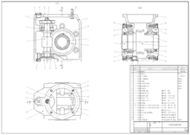](https://en.wikipedia.org/wiki/File:Schneckengetriebe.png)

Fig no 3.1.1. Example**:**  2D CAD drawing

[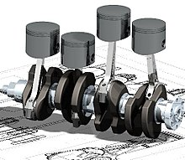](https://en.wikipedia.org/wiki/File:Cad_crank.jpg)

Fig no 3.1.2. Example**:** 3D CAD model

**3.2. Overview of CAD software:**

Starting around the mid-1970s, as computer-aided design systems began to provide more capability than just an ability to reproduce manual drafting with electronic drafting, the cost-benefit for companies to switch to CAD became apparent. The benefits of CAD systems over manual drafting are the capabilities one often takes for granted from computer systems today; automated generation of [Bill of Material](https://en.wikipedia.org/wiki/Bill_of_Material), auto layout in [integrated circuits](https://en.wikipedia.org/wiki/Integrated_circuits), interference checking, and many others. Eventually, CAD provided the designer with the ability to perform engineering calculations. During this transition, calculations were still performed either by hand or by those individuals who could run computer programs. CAD was a revolutionary change in the engineering industry, where draftsmen, designers and engineering roles begin to merge. It did not eliminate departments, as much as it merged departments and empowered draftsman, designers and engineers. CAD is just another example of the pervasive effect computers were beginning to have on industry. Current computer-aided design software packages range from 2D [vector](https://en.wikipedia.org/wiki/Vector_graphics)-based drafting systems to 3D [solid](https://en.wikipedia.org/wiki/Solid_modeling) and [surface](https://en.wikipedia.org/wiki/Freeform_surface_modelling) modelers. Modern CAD packages can also frequently allow rotations in three dimensions, allowing viewing of a designed object from any desired angle, even from the inside looking out. Some CAD software is capable of dynamic mathematical modeling.

CAD technology is used in the design of tools and machinery and in the drafting and design of all types of buildings, from small residential types (houses) to the largest commercial and industrial structures (hospitals and factories).

CAD is mainly used for detailed engineering of 3D models or 2D drawings of physical components, but it is also used throughout the engineering process from conceptual design and layout of products, through strength and dynamic analysis of assemblies to definition of manufacturing methods of components. It can also be used to design objects such as jewelry, furniture, appliances, etc. Furthermore, many CAD applications now offer advanced rendering and animation capabilities so engineers can better visualize their product designs. [4D BIM](https://en.wikipedia.org/wiki/4D_BIM) is a type of virtual construction engineering simulation incorporating time or schedule related information for project management.

CAD has become an especially important technology within the scope of [computer-aided technologies](https://en.wikipedia.org/wiki/CAx), with benefits such as lower product development costs and a greatly shortened [design cycle](https://en.wikipedia.org/wiki/Systems_development_life_cycle#Design). CAD enables designers to layout and develop work on screen, print it out and save it for future editing, saving time on their drawings.

**3.2.1. Uses**

Computer-aided design is one of the many tools used by engineers and designers and is used in many ways depending on the profession of the user and the type of software in question.

CAD is one part of the whole Digital Product Development (DPD) activity within the [Product Lifecycle Management](https://en.wikipedia.org/wiki/Product_Lifecycle_Management) (PLM) processes, and as such is used together with other tools, which are either integrated modules or stand-alone products, such as:

* [Computer-aided engineering](https://en.wikipedia.org/wiki/Computer-aided_engineering) (CAE) and [Finite element analysis](https://en.wikipedia.org/wiki/Finite_element_analysis) (FEA)
* [Computer-aided manufacturing](https://en.wikipedia.org/wiki/Computer-aided_manufacturing) (CAM) including instructions to [Computer Numerical Control](https://en.wikipedia.org/wiki/Computer_Numerical_Control) (CNC) machines
* [Photorealistic rendering](https://en.wikipedia.org/wiki/Photorealistic_rendering) and Motion Simulation.
* Document management and [revision control](https://en.wikipedia.org/wiki/Revision_control) using [Product Data Management](https://en.wikipedia.org/wiki/Product_Data_Management) (PDM).

CAD is also used for the accurate creation of photo simulations that are often required in the preparation of Environmental Impact Reports, in which computer-aided designs of intended buildings are superimposed into photographs of existing environments to represent what that locale will be like, where the proposed facilities are allowed to be built. Potential blockage of view corridors and shadow studies are also frequently analyzed through the use of CAD.

CAD has been proven to be useful to engineers as well. Using four properties which are history, features, parameterization, and high-level constraints. The construction history can be used to look back into the model's personal features and work on the single area rather than the whole model. Parameters and constraints can be used to determine the size, shape, and other properties of the different modeling elements. The features in the CAD system can be used for the variety of tools for measurement such as tensile strength, yield strength, electrical or electromagnetic properties. Also its stress, strain, [timing](https://en.wikipedia.org/wiki/Timing_closure) or how the element gets affected in certain temperatures, etc.

**3.2.2. Types**

[](https://en.wikipedia.org/wiki/File:CAD_Modeling.gif)

3.2.2.1 A simple procedure

There are several different types of CAD, each requiring the operator to think differently about how to use them and design their virtual components in a different manner for each.

There are many producers of the lower-end 2D systems, including a number of free and open source programs. These provide an approach to the drawing process without all the fuss over scale and placement on the drawing sheet that accompanied hand drafting since these can be adjusted as required during the creation of the final draft.

3D [wireframe](https://en.wikipedia.org/wiki/Wire-frame_model) is basically an extension of 2D drafting (not often used today). Each line has to be manually inserted into the drawing. The final product has no mass properties associated with it and cannot have features directly added to it, such as holes. The operator approaches these in a similar fashion to the 2D systems, although many 3D systems allow using the wireframe model to make the final engineering drawing views.

3D "dumb" solids are created in a way analogous to manipulations of real-world objects (not often used today). Basic three-dimensional geometric forms (prisms, cylinders, spheres, and so on) have solid volumes added or subtracted from them as if assembling or cutting real-world objects. Two-dimensional projected views can easily be generated from the models. Basic 3D solids don't usually include tools to easily allow motion of components, set limits to their motion, or identify interference between components.

There are two types of [3D Solid Modeling](https://en.wikipedia.org/wiki/Solid_modeling)

1. Parametric modeling allows the operator to use what is referred to as "design intent". The objects and features created are modifiable. Any future modifications can be made by changing how the original part was created. If a feature was intended to be located from the center of the part, the operator should locate it from the center of the model. The feature could be located using any geometric object already available in the part, but this random placement would defeat the design intent. If the operator designs the part as it functions the parametric modeler is able to make changes to the part while maintaining geometric and functional relationships.
2. [Direct or Explicit modeling](https://en.wikipedia.org/wiki/Explicit_modeling) provide the ability to edit geometry without a history tree. With direct modeling, once a sketch is used to create geometry the sketch is incorporated into the new geometry and the designer just modifies the geometry without needing the original sketch. As with parametric modeling, [direct modeling](https://en.wikipedia.org/w/index.php?title=Direct_modeling&action=edit&redlink=1) has the ability to include relationships between selected geometry (e.g., tangency, concentricity).

Top end systems offer the capabilities to incorporate more organic, aesthetics and ergonomic features into designs. [Freeform surface modeling](https://en.wikipedia.org/wiki/Freeform_surface_modeling) is often combined with solids to allow the designer to create products that fit the human form and visual requirements as well as they interface with the machine.

**3.2.3. Technology**

[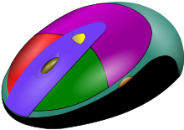](https://en.wikipedia.org/wiki/File:Cad_mouse_1.svg)

Fig no 3.2.3.1 A CAD model of a [computer mouse](https://en.wikipedia.org/wiki/Mouse_(computing)).

Originally software for Computer-Aided Design systems was developed with computer languages such as [Fortran](https://en.wikipedia.org/wiki/Fortran), [ALGOL](https://en.wikipedia.org/wiki/ALGOL) but with the advancement of [object-oriented programming](https://en.wikipedia.org/wiki/Object-oriented_programming) methods this has radically changed. Typical modern [parametric feature-based modeler](https://en.wikipedia.org/w/index.php?title=Parametric_feature-based_modeler&action=edit&redlink=1) and [freeform surface](https://en.wikipedia.org/wiki/Freeform_surface) systems are built around a number of key [C](https://en.wikipedia.org/wiki/C_(programming_language)) modules with their own [APIs](https://en.wikipedia.org/wiki/Application_programming_interface). A CAD system can be seen as built up from the interaction of a [graphical user interface](https://en.wikipedia.org/wiki/Graphical_user_interface) (GUI) with [NURBS](https://en.wikipedia.org/wiki/NURBS" \o "NURBS)geometry or [boundary representation](https://en.wikipedia.org/wiki/Boundary_representation) (B-rep) data via a [geometric modeling kernel](https://en.wikipedia.org/wiki/Geometric_modeling_kernel). A geometry constraint engine may also be employed to manage the associative relationships between geometry, such as wireframe geometry in a sketch or components in an assembly.

Unexpected capabilities of these associative relationships have led to a new form of [prototyping](https://en.wikipedia.org/wiki/Prototyping) called [digital prototyping](https://en.wikipedia.org/wiki/Digital_prototyping). In contrast to physical prototypes, which entail manufacturing time in the design. That said, CAD models can be generated by a computer after the physical prototype has been scanned using an [industrial CT scanning](https://en.wikipedia.org/wiki/Industrial_CT_scanning) machine. Depending on the nature of the business, digital or physical prototypes can be initially chosen according to specific needs.

Today, CAD systems exist for all the major platforms ([Windows](https://en.wikipedia.org/wiki/Microsoft_Windows), [Linux](https://en.wikipedia.org/wiki/Linux), [UNIX](https://en.wikipedia.org/wiki/UNIX) and [Mac OS X](https://en.wikipedia.org/wiki/Mac_OS_X)); some packages support multiple platforms.

Right now, no special hardware is required for most CAD software. However, some CAD systems can do graphically and computationally intensive tasks, so a modern [graphics card](https://en.wikipedia.org/wiki/Graphics_card), high speed (and possibly multiple) [CPUs](https://en.wikipedia.org/wiki/Central_processing_unit) and large amounts of [RAM](https://en.wikipedia.org/wiki/Random-access_memory) may be recommended.

The human-machine interface is generally via a [computer mouse](https://en.wikipedia.org/wiki/Computer_mouse) but can also be via a pen and digitizing [graphics tablet](https://en.wikipedia.org/wiki/Graphics_tablet). Manipulation of the view of the model on the screen is also sometimes done with the use of a [Spacemouse/SpaceBall](https://en.wikipedia.org/wiki/3Dconnexion" \o "3Dconnexion). Some systems also support stereoscopic glasses for [viewing the 3D model](https://en.wikipedia.org/wiki/Scientific_visualization).Technologies which in the past were limited to larger installations or specialist applications have become available to a wide group of users. These include the [CAVE](https://en.wikipedia.org/wiki/Cave_automatic_virtual_environment) or [HMDs](https://en.wikipedia.org/wiki/Virtual_reality) and interactive [devices](https://en.wikipedia.org/wiki/Leap_Motion) like motion-sensing [technology](https://en.wikipedia.org/wiki/Kinect)

**3.2.4. CAD Software:**

CAD software enables engineers and architects to design, inspect and manage engineering projects within an integrated [graphical user interface](https://en.wikipedia.org/wiki/Graphical_user_interface) (GUI) on a [personal computer](https://en.wikipedia.org/wiki/Personal_computer) system. Most applications support [solid modeling](https://en.wikipedia.org/wiki/Solid_modeling) with [boundary representation](https://en.wikipedia.org/wiki/Boundary_representation) (B-Rep) and [NURBS](https://en.wikipedia.org/wiki/NURBS) geometry, and enable the same to be published in a variety of formats. A [geometric modeling kernel](https://en.wikipedia.org/wiki/Geometric_modeling_kernel) is a software component that provides solid modeling and surface modeling features to CAD applications.

Based on market statistics, [commercial software](https://en.wikipedia.org/wiki/Commercial_software) from Autodesk, Dassault Systems, Siemens PLM Software, and PTC dominate the CAD industry. The following is a list of major CAD applications, grouped by usage statistics.

**3.2.4.1. Commercial Software’s**

* [Alibre Design](https://en.wikipedia.org/wiki/Alibre_Design)
* Autodesk [AutoCAD](https://en.wikipedia.org/wiki/AutoCAD)
* [Autodesk Inventor](https://en.wikipedia.org/wiki/Autodesk_Inventor)
* [Bentley Systems](https://en.wikipedia.org/wiki/Bentley_Systems) Micro Station
* Bricsys [BricsCAD](https://en.wikipedia.org/wiki/BricsCAD)
* Dassault Systemes [CATIA](https://en.wikipedia.org/wiki/CATIA)
* Dassault Systemes [SolidWorks](https://en.wikipedia.org/wiki/SolidWorks)
* Kubotek [KeyCreator](https://en.wikipedia.org/wiki/KeyCreator)
* [Siemens NX](https://en.wikipedia.org/wiki/Siemens_NX)
* Siemens [Solid Edge](https://en.wikipedia.org/wiki/Solid_Edge)
* PTC  [Cero](https://en.wikipedia.org/wiki/PTC_Creo) (formerly known as Pro/ENGINEER)
* Trimble [Sketch Up](https://en.wikipedia.org/wiki/SketchUp)
* AgileCity [Modelur](https://en.wikipedia.org/wiki/Modelur)
* [Turbo CAD](https://en.wikipedia.org/wiki/TurboCAD)
* [IRONCAD](https://en.wikipedia.org/wiki/IRONCAD)
* [MEDUSA](https://en.wikipedia.org/wiki/MEDUSA)
* [Proge CAD](https://en.wikipedia.org/wiki/ProgeCAD)
* [Space Claim](https://en.wikipedia.org/wiki/SpaceClaim)
* [Punch CAD](https://en.wikipedia.org/wiki/PunchCAD)
* [Rhinoceros 3D](https://en.wikipedia.org/wiki/Rhinoceros_3D)
* [VariCAD](https://en.wikipedia.org/wiki/VariCAD)
* [Vectorwrks](https://en.wikipedia.org/wiki/Vectorworks)
* [Cobalt](https://en.wikipedia.org/wiki/Cobalt_(CAD_program))
* [Gravotech Type3](https://en.wikipedia.org/w/index.php?title=Gravotech_Type3&action=edit&redlink=1)
* [RoutCad](https://en.wikipedia.org/wiki/RoutCad)
* [SketchUp](https://en.wikipedia.org/wiki/SketchUp)
* [Onshape](https://en.wikipedia.org/wiki/Onshape)
* [ActCAD](https://en.wikipedia.org/w/index.php?title=ActCAD&action=edit&redlink=1)
* [Remo 3D](https://en.wikipedia.org/wiki/Remo_3D)

**3.2.4.2. Freeware and open source**

* [123D](https://en.wikipedia.org/wiki/123D)
* [LibreCAD](https://en.wikipedia.org/wiki/LibreCAD)
* [FreeCAD](https://en.wikipedia.org/wiki/FreeCAD)
* [BRL-CAD](https://en.wikipedia.org/wiki/BRL-CAD)
* [OpenSCAD](https://en.wikipedia.org/wiki/OpenSCAD)
* [QCad](https://en.wikipedia.org/wiki/QCad)
* [SolveSpace](https://en.wikipedia.org/wiki/SolveSpace)

**3.2.4.3. CAD kernels**

* [Parasolid](https://en.wikipedia.org/wiki/Parasolid) by Siemens
* [ACIS](https://en.wikipedia.org/wiki/ACIS) by Spatial
* [Shape Manager](https://en.wikipedia.org/wiki/ShapeManager) by Autodesk
* [Open CASCADE](https://en.wikipedia.org/wiki/Open_CASCADE)
* [C3D](https://en.wikipedia.org/wiki/C3D_Toolkit) by C3D Labs

**3.3 History**

Designers have long used computers for their calculations. [Digital computers](https://en.wikipedia.org/wiki/Claude_Shannon) were used in power system analysis or optimization as early as proto-"[Whirlwind](https://en.wikipedia.org/wiki/Whirlwind_(computer))" in [1949](https://en.wikipedia.org/wiki/Network_analyzer_(AC_power)). Circuit [design](https://en.wikipedia.org/wiki/Digital_electronics) theory, or [power network](https://en.wikipedia.org/wiki/Charles_Proteus_Steinmetz) methodology would be [algebraic](https://en.wikipedia.org/wiki/Linear_algebra), [symbolic](https://en.wikipedia.org/wiki/Quine%E2%80%93McCluskey_algorithm), and often [vector](https://en.wikipedia.org/wiki/Euclidean_vector)-based. Examples of problems being solved in the mid-1940s to 50s include: servo motors controlled by generated pulse (1949), a digital computer with built-in computer operations to automatically co-ordinate transforms to compute radar related vectors (1951) and the essentially graphic mathematical process of forming a shape with a digital machine tool (1952). These were accomplished with the use of computer software. The man credited with coining the term CAD. [Douglas T. Ross](https://en.wikipedia.org/wiki/Douglas_T._Ross) stated "As soon as I saw the interactive display equipment," [being used by radar operators 1953] it would be just what his data reduction group needed. With the Lincoln Lab people, they were the only ones who used the big, complex display systems put in for the pre-SAGE, Cape Cod system. But "we used it for our own personal workstation".  The designers of these very early computers built utility programs so that programmers could debug programs using flowcharts on a display scope with logical switches that could be opened and closed during the debugging session. They found that they could create electronic symbols and geometric figures to be used to create simple circuit diagrams and flowcharts. They made the pleasant discovery that an object once drawn could be reproduced at will, its orientation, Linkage [ [flux](https://en.wikipedia.org/wiki/Flux_linkage" \o "Flux linkage), [mechanical](https://en.wikipedia.org/wiki/Linkage_(mechanical)), [lexical scoping](https://en.wikipedia.org/wiki/Linkage_(software)) ] or scale changed. This suggested numerous possibilities to them. It took ten years of interdisciplinary development work before SKETCHPAD sitting on evolving math libraries emerged from MIT's labs. Additional developments were carried out in the 1960s within the aircraft, automotive, industrial control and electronics industries in the area of 3D surface construction, NC programming, and design analysis, most of it independent of one another and often not publicly published until much later. Some of the mathematical description work on curves was developed in the early 1940s by Robert Isaac Newton from Pawtucket, Rhode Island. [Robert A. Heinlein](https://en.wikipedia.org/wiki/Robert_A._Heinlein) in his 1957 novel The Door into summer suggested the possibility of a robotic Drafting Dan. However, probably the most important work on polynomial curves and sculptured surface was done by [Pierre Bezier](https://en.wikipedia.org/wiki/Pierre_B%C3%A9zier), [Paul de Casteljau](https://en.wikipedia.org/wiki/Paul_de_Casteljau) ([Citroen](https://en.wikipedia.org/wiki/Citroen)), [Steven Anson Coons](https://en.wikipedia.org/wiki/Steven_Anson_Coons) ([MIT](https://en.wikipedia.org/wiki/Massachusetts_Institute_of_Technology), [Ford](https://en.wikipedia.org/wiki/Ford_Motor_Company)), James Ferguson ([Boeing](https://en.wikipedia.org/wiki/Boeing)), [Carl de Boor](https://en.wikipedia.org/wiki/Carl_de_Boor) ([GM](https://en.wikipedia.org/wiki/General_Motors)), Birkhoff (GM) and Garibedian (GM) in the 1960s and W. Gordon (GM) and R. Riesenfeld in the 1970s.

The invention of the 3D CAD/CAM is attributed to a French engineer, [Pierre Bezier](https://en.wikipedia.org/wiki/Pierre_B%C3%A9zier) ([Arts et Métiers Aristech](https://en.wikipedia.org/wiki/Arts_et_M%C3%A9tiers_ParisTech), Renault). After his mathematical work concerning surfaces, he developed [UNISURF](https://en.wikipedia.org/wiki/UNISURF), between 1966 and 1968, to ease the design of parts and tools for the automotive industry. Then, UNISURF became the working base for the following generations of CAD software.

It is argued that a turning point was the development of the [SKETCHPAD](https://en.wikipedia.org/wiki/Sketchpad) system at [MIT](https://en.wikipedia.org/wiki/Massachusetts_Institute_of_Technology) by [Ivan Sutherland](https://en.wikipedia.org/wiki/Ivan_Sutherland) (who later created a graphics technology company with David Evans). The distinctive feature of SKETCHPAD was that it allowed the designer to interact with his computer graphically: the design can be fed into the computer by drawing on a [CRT](https://en.wikipedia.org/wiki/Cathode_ray_tube) [monitor](https://en.wikipedia.org/wiki/Computer_display) with a [light pen](https://en.wikipedia.org/wiki/Light_pen). Effectively, it was a prototype of [graphical user interface](https://en.wikipedia.org/wiki/Graphical_user_interface), an indispensable feature of modern CAD. Sutherland presented his paper Sketchpad: A Man-Machine Graphical Communication System in 1963 at a [Joint Computer Conference](https://en.wikipedia.org/wiki/Joint_Computer_Conference)having worked on it as his PhD thesis paper for a few years. Quoting, "For drawings where motion of the drawing or analysis of a drawn problem is of value to the user, Sketchpad excels. For highly repetitive drawings or drawings where accuracy is required, Sketchpad is sufficiently faster than conventional techniques to be worthwhile. For drawings which merely communicate with shops, it is probably better to use conventional paper and pencil." Over time efforts would be directed toward the goal of having the [designers drawings communicate](https://en.wikipedia.org/wiki/Autodesk_123D) not just with shops but with the [shop tool](https://en.wikipedia.org/wiki/STEP-NC) itself. This goal would be a long time arriving.

The first commercial applications of CAD were in large companies in the automotive and aerospace industries, as well as in electronics. Only large corporations could afford the computers capable of performing the calculations. Notable company projects were, a joint project of [GM](https://en.wikipedia.org/wiki/General_Motors_Corporation) ([Patrick J. Hanratty](https://en.wikipedia.org/wiki/Patrick_J._Hanratty)) and [IBM](https://en.wikipedia.org/wiki/IBM) ([Sam Matsa](http://www.siggraph.org/publications/newsletter/v32n1/columns/machover.html), Doug Ross's [MIT](https://en.wikipedia.org/wiki/Massachusetts_Institute_of_Technology) APT research assistant) to develop a prototype system for design engineers [DAC-1](https://en.wikipedia.org/wiki/DAC-1) (Design Augmented by Computer) 1964; [Lockheed](https://en.wikipedia.org/wiki/Lockheed_Corporation) projects; [Bell](https://en.wikipedia.org/wiki/Nokia_Bell_Labs) GRAPHIC 1 and [Renault](https://en.wikipedia.org/wiki/Renault).

One of the most influential events in the development of CAD was the founding of MCS (Manufacturing and Consulting Services Inc.) in 1971 by Patrick J. Hanratty, who wrote the system ADAM (Automated Drafting And Machining) but more importantly supplied code to companies such as [McDonnell Douglas](https://en.wikipedia.org/wiki/McDonnell_Douglas)([Unigraphics](https://en.wikipedia.org/wiki/Unigraphics)), [Computervision](https://en.wikipedia.org/wiki/Computervision) ([CADDS](https://en.wikipedia.org/wiki/CADDS)), [Calma](https://en.wikipedia.org/wiki/Calma), [Gerber](https://en.wikipedia.org/wiki/Gerber_Scientific), [Autotrol](https://en.wikipedia.org/w/index.php?title=Auto-Trol_Technology&action=edit&redlink=1) and [Control Data](https://en.wikipedia.org/wiki/Control_Data_Corporation).

As computers became more affordable, the application areas have gradually expanded. The development of CAD software for personal desktop computers was the impetus for almost universal application in all areas of construction.

Other key points in the 1960s and 1970s would be the foundation of CAD systems [United Computing](https://en.wikipedia.org/wiki/UGS_Corp.), [Intergraph](https://en.wikipedia.org/wiki/Intergraph), [IBM](https://en.wikipedia.org/wiki/IBM), Intergraph IGDS in 1974 (which led to [Bentley Systems](https://en.wikipedia.org/wiki/Bentley_Systems) [Micro Station](https://en.wikipedia.org/wiki/MicroStation) in 1984).

CAD implementations have evolved dramatically since then. Initially, with 3D in the 1970s, it was typically limited to producing drawings similar to hand-drafted drawings. Advances in programming and computer hardware, notably solid modeling in the 1980s have allowed more versatile applications of computers in design activities.

Key products for 1981 were the solid modeling packages - [Romulus](https://en.wikipedia.org/wiki/Romulus_(b-rep_solid_modeler)) (ShapeData) and Uni-Solid (Unigraphics) based on PADL-2 and the release of the surface modeler [CATIA](https://en.wikipedia.org/wiki/CATIA) ([Dassault Systemes](https://en.wikipedia.org/wiki/Dassault_Systemes)). Autodesk was founded 1982 by John Walker, which led to the 2D system [AutoCAD](https://en.wikipedia.org/wiki/AutoCAD). The next milestone was the release of [Pro/ENGINEER](https://en.wikipedia.org/wiki/Pro/ENGINEER) in 1987, which heralded greater usage of feature-based modeling methods and parametric linking of the parameters of features. Also of importance to the development of CAD was the development of the B-rep solid modeling kernels (engines for manipulating geometrically and topologically consistent 3D objects) [Parasolid](https://en.wikipedia.org/wiki/Parasolid) (Shape Data) and [ACIS](https://en.wikipedia.org/wiki/ACIS) (Spatial Technology Inc.) at the end of the 1980s and beginning of the 1990s, both inspired by the work of Ian Braid. This led to the release of mid-range packages such as [SolidWorks](https://en.wikipedia.org/wiki/SolidWorks) and TriSpective (later known as [IRONCAD](https://en.wikipedia.org/wiki/Ironcad)) in 1995, [Solid Edge](https://en.wikipedia.org/wiki/Solid_Edge) (then [Intergraph](https://en.wikipedia.org/wiki/Intergraph)) in 1996 and [Autodesk Inventor](https://en.wikipedia.org/wiki/Autodesk_Inventor) in 1999. An independent [geometric modeling kernel](https://en.wikipedia.org/wiki/Geometric_modeling_kernel) has been evolving in Russia since the 1990s.

**3.4 INTRODUCTION OF CATIA**

CATIA also known as Computer Aided Three-dimensional Interactive Application and it is software suit that developed by the French company call Desalt Systems. Company such as Siemens NX, Cero Elements/Pro and Autodesk Inventor is competitor of CATIA. CATIA is a process-centric computer-aided design/computer-assisted manufacturing/computer-aided engineering CAD/CAM/CAE) system that fully uses next generation object technologies and leading-edge industry standards. CATIA is integrated with Dussault Systems Product Lifecycle Management (PLM) solutions. It allows the users to simulate their industrial design processes from initial concept to product design, analysis, assembly and also maintenance. In this software, it includes mechanical, and shape design, styling, product synthesis, equipment and systems engineering, NC manufacturing, analysis and simulation, and industrial plant design. It is a very user friendly software because CATIA Knowledge ware allows broad communities of user to easily capture and share know-how, rules, and other intellectual property assets.

Commonly referred to as a [3D](https://en.wikipedia.org/wiki/Dimension) [Product Lifecycle Management](https://en.wikipedia.org/wiki/Product_Lifecycle_Management) software suite, CATIA supports multiple stages of product development ([CAx](https://en.wikipedia.org/wiki/CAx" \o "CAx)), including conceptualization, design ([CAD](https://en.wikipedia.org/wiki/Computer-aided_design)), engineering ([CAE](https://en.wikipedia.org/wiki/Computer-aided_engineering)) and manufacturing ([CAM](https://en.wikipedia.org/wiki/Computer-aided_manufacturing)). CATIA facilitates collaborative engineering across disciplines around its 3DEXPERIENCE platform, including surfacing & shape design, electrical, fluid and electronic systems design, [mechanical engineering](https://en.wikipedia.org/wiki/Mechanical_engineering) and [systems engineering](https://en.wikipedia.org/wiki/Systems_engineering).

CATIA facilitates the design of electronic, electrical, and distributed systems such as fluid and [HVAC](https://en.wikipedia.org/wiki/HVAC) systems, all the way to the production of documentation for manufacturing.

**3.2.1 Applications of CATIA:**

**3.2.1.1 Mechanical engineering**

CATIA enables the creation of 3D parts, from 3D sketches, [sheet metal](https://en.wikipedia.org/wiki/Sheet_metal), [composites](https://en.wikipedia.org/wiki/Composite_material), and molded, forged or tooling parts up to the definition of mechanical assemblies. The software provides advanced technologies for mechanical surfacing & [BIW](https://en.wikipedia.org/wiki/Body_in_white). It provides tools to complete product definition, including functional tolerances as well as [kinematics](https://en.wikipedia.org/wiki/Kinematics) definition. CATIA provides a wide range of applications for tooling design, for both generic [tooling](https://en.wikipedia.org/wiki/Tool_management) and mold & die. In the case of Aerospace engineering an additional module named the aerospace sheet metal design offers the user combine the capabilities of generative sheet metal design and generative surface design.

**3.2.1.2 Design**

CATIA offers a solution to shape design, styling, surfacing workflow and visualization to create, modify, and validate complex innovative shapes from industrial design to [Class-A surfacing](https://en.wikipedia.org/wiki/Class_A_surfaces) with the ICEM surfacing technologies. CATIA supports multiple stages of product design whether started from scratch or from 2D sketches (blueprints). 

**3.2.1.3 Systems engineering**

The CATIA Systems Engineering solution delivers a unique open and extensible systems engineering development platform that fully integrates the cross-discipline modeling, simulation, verification and business process support needed for developing complex ‘cyber-physical’ products. It enables organizations to evaluate requests for changes or develop new products or system variants utilizing a unified performance based systems engineering approach. The solution addresses the Model Based Systems Engineering (MBSE) needs of users developing today’s smart products and systems and comprises the following elements: [Requirements Engineering](https://en.wikipedia.org/wiki/Requirements_Engineering), [Systems Architecture](https://en.wikipedia.org/wiki/Systems_Architecture) Modeling, Systems Behavior Modeling & Simulation, Configuration Management & Lifecycle Traceability, Automotive Embedded Systems Development (AUTOSAR Builder) and Industrial [Automation](https://en.wikipedia.org/wiki/Automation) Systems Development (Control Build).

CATIA uses the open [Modelica](https://en.wikipedia.org/wiki/Modelica) language in both CATIA Dynamic Behavior Modeling and [Dymola](https://en.wikipedia.org/wiki/Dymola), to quickly and easily model and simulate the behavior of complex systems that span multiple engineering discipline. CATIA & [Dymola](https://en.wikipedia.org/wiki/Dymola) are further extended by through the availability of a number of industry and domain specific [Modelica](https://en.wikipedia.org/wiki/Modelica) libraries that enable user to model and simulate a wide range of complex systems – ranging from automotive vehicle dynamics through to aircraft flight dynamics.

**3.2.1.4 Electrical systems**

CATIA v5 offers a solution to formulate the design and manufacturing of electrical systems spanning the complete process from conceptual design through to manufacturing. Capabilities include requirements capture, electrical schematic definition, interactive 3D routing of both wire harnesses and industrial cable solutions through to the production of detailed manufacturing documents including form boards.

**3.2.1.5 Fluid systems**

CATIA offers a solution to facilitate the design and manufacturing of routed systems including tubing, piping, Heating, Ventilating & Air Conditioning ([HVAC](https://en.wikipedia.org/wiki/HVAC)). Capabilities include requirements capture, 2D diagrams for defining hydraulic, pneumatic and [HVAC](https://en.wikipedia.org/wiki/HVAC) systems, as well as [Piping and Instrumentation Diagram](https://en.wikipedia.org/wiki/Piping_and_Instrumentation_Diagram) (P&ID). Powerful capabilities are provided that enables these 2D diagrams to be used to drive the interactive 3D routing and placing of system components, in the context of the digital mockup of the complete product or process plant, through to the delivery of manufacturing information including reports and piping isometric drawings.

**3.2.1.6 Industries**

CATIA can be applied to a wide variety of industries, from aerospace and defense, automotive, and industrial equipment, to high tech, shipbuilding, consumer goods, plant design, consumer packaged goods, life sciences, architecture and construction, process power and petroleum, and services. CATIA V4, CATIA V5, [Pro/ENGINEER](https://en.wikipedia.org/wiki/Pro/ENGINEER), [NX](https://en.wikipedia.org/wiki/NX_(software)) (formerly Unigraphics), and Dassault Systemes' own [SolidWorks](https://en.wikipedia.org/wiki/SolidWorks) platform are the dominant systems

**3.2.1.7 Aerospace**

[The Boeing Company](https://en.wikipedia.org/wiki/Boeing) used CATIA V3 to develop its [777](https://en.wikipedia.org/wiki/Boeing_777) airliner and used CATIA V5 for the [787](https://en.wikipedia.org/wiki/Boeing_787_Dreamliner) series aircraft. They have employed the full range of Dassault Systemes' 3D PLM products – CATIA, [DELMIA](https://en.wikipedia.org/wiki/DELMIA), and [ENOVIA LCA](https://en.wikipedia.org/wiki/ENOVIA_MatrixOne) – supplemented by Boeing-developed applications.

* The development of the Indian Light Combat Aircraft has used CATIA V5.
* Chinese [Xian JH-7](https://en.wikipedia.org/wiki/Xian_JH-7)A was the first aircraft developed by CATIA V5 when the design was completed on September 26, 2000.
* European aerospace [Airbus](https://en.wikipedia.org/wiki/Airbus) is also using CATIA.
* Canadian aircraft maker [Bombardier Aerospace](https://en.wikipedia.org/wiki/Bombardier_Aerospace) has done all of its aircraft design on CATIA V5.
* [BAE Systems](https://en.wikipedia.org/wiki/BAE_Systems) uses CATIA.
* The Brazilian aircraft company [Embraer](https://en.wikipedia.org/wiki/Embraer) uses CATIA V4 and V5 to build all airplanes.
* [FNSS](https://en.wikipedia.org/wiki/FNSS) is using CATIA V5 and V6.
* [Vought](https://en.wikipedia.org/wiki/Vought) Aircraft Industries uses CATIA V4 and V5 to produce its parts.
* The Anglo/Italian Helicopter company [AgustaWestland](https://en.wikipedia.org/wiki/AgustaWestland) uses CATIA V4 and V5 to design their full range of aircraft.
* All subsidiaries of the French company [Safran](https://en.wikipedia.org/wiki/Safran) use CATIA for a full range of aerospace, defence and security products.
* The [Eurofighter Typhoon](https://en.wikipedia.org/wiki/Eurofighter_Typhoon) has been designed using both CATIA V4 and V5.
* The main supplier of helicopters to the U.S Military forces, Sikorsky Aircraft Corp., uses CATIA as well.
* P3 Voith is using CATIA V6 electrical.
* [Bell Helicopter](https://en.wikipedia.org/wiki/Bell_Helicopter), the creator of the [Bell Boeing V-22 Osprey](https://en.wikipedia.org/wiki/Bell_Boeing_V-22_Osprey), has used CATIA V4, V5 and V6.

Of course, [Dassault Aviation](https://en.wikipedia.org/wiki/Dassault_Aviation) is also using CATIA and they are currently working on CATIA V6.

**3.2.1.7 Automotive**

Many automotive companies use CATIA to varying degrees, including [BMW](https://en.wikipedia.org/wiki/BMW), [Porsche](https://en.wikipedia.org/wiki/Porsche), [McLaren Automotive](https://en.wikipedia.org/wiki/McLaren_Automotive), [Chrysler](https://en.wikipedia.org/wiki/Chrysler), [Honda](https://en.wikipedia.org/wiki/Honda), [Audi](https://en.wikipedia.org/wiki/Audi), [Jaguar Land Rover](https://en.wikipedia.org/wiki/Land_Rover), [Volkswagen](https://en.wikipedia.org/wiki/Volkswagen), [SEAT](https://en.wikipedia.org/wiki/SEAT), [Skoda](https://en.wikipedia.org/wiki/%C5%A0koda_Auto), [Bentley Motors Limited](https://en.wikipedia.org/wiki/Bentley_Motors_Limited), [Volvo](https://en.wikipedia.org/wiki/Volvo), [Fiat](https://en.wikipedia.org/wiki/Fiat), [Bentlee International](https://en.wikipedia.org/wiki/Benteler_International), [Renault](https://en.wikipedia.org/wiki/Renault), [Toyota](https://en.wikipedia.org/wiki/Toyota_Motor_Corporation), [Ford](https://en.wikipedia.org/wiki/Ford_Motor_Company), [Scania](https://en.wikipedia.org/wiki/Scania_AB), [Hyundai](https://en.wikipedia.org/wiki/Hyundai_Motor_Company), [Tesla Motors](https://en.wikipedia.org/wiki/Tesla_Motors), [Rolls-Royce Motors](https://en.wikipedia.org/wiki/Rolls-Royce_Motors),  [Valmet Automotive](https://en.wikipedia.org/wiki/Valmet_Automotive), [Proton](https://en.wikipedia.org/wiki/Proton_(carmaker)), Elba, [Tata motors](https://en.wikipedia.org/wiki/Tata_motors) and [Mahindra & Mahindra Limited](https://en.wikipedia.org/wiki/Mahindra_%26_Mahindra_Limited). [Goodyear](https://en.wikipedia.org/wiki/Goodyear_Tire_and_Rubber_Company) uses it in making tires for automotive and aerospace and also uses a customized CATIA for its design and development. Many automotive companies use CATIA for car structures – door beams, IP supports, bumper beams, roof rails, side rails, body components because of CATIA's capabilities in [Computer representation of surfaces](https://en.wikipedia.org/wiki/Computer_representation_of_surfaces). [Bombardier Transportation](https://en.wikipedia.org/wiki/Bombardier_Transportation) of Canada is using this software to design its entire fleet of Train engines and coaches. [Webasto](https://en.wikipedia.org/wiki/OASys_(company)) uses CATIA to design its roof.

**3.2.1.8 Shipbuilding**

Dassault Systemes has begun serving shipbuilders with CATIA V5 release 8, which includes special features useful to shipbuilders. [GD Electric Boat](https://en.wikipedia.org/wiki/Electric_Boat) used CATIA to design the latest fast attack submarine class for the [United States Navy](https://en.wikipedia.org/wiki/United_States_Navy), the [Virginia class](https://en.wikipedia.org/wiki/Virginia_class_submarine). [Newport News Shipbuilding](https://en.wikipedia.org/wiki/Newport_News_Shipbuilding) also used CATIA to design the [Gerald R. Ford class](https://en.wikipedia.org/wiki/Gerald_R._Ford_class_aircraft_carrier) of [supercarriers](https://en.wikipedia.org/wiki/Supercarrier) for the US Navy. In 2004, it has been adopted by the [Beneteau](https://en.wikipedia.org/wiki/Beneteau) Group for development of new sailing and leisure motor boats.

**3.2.1.9 Industrial equipment**

CATIA has a strong presence in the Industrial Equipment industry. [Industrial Manufacturing machinery](https://en.wikipedia.org/wiki/Manufacturing) companies like Schuler and [Metso](https://en.wikipedia.org/wiki/Metso) use CATIA, as do heavy mobile machinery and equipment companies like [Claas](https://en.wikipedia.org/wiki/Claas), and also various industrial equipment product companies like [Alstom Power](https://en.wikipedia.org/wiki/Alstom_Power) and [ABB Group](https://en.wikipedia.org/wiki/ABB_Group). [Michelin](https://en.wikipedia.org/wiki/Michelin) is also using CATIA for its production.

**3.2.1.10 High tech**

Some high tech companies are using CATIA to design their products. You can find for example: [Nikon](https://en.wikipedia.org/wiki/Nikon), [Nokia](https://en.wikipedia.org/wiki/Nokia), [and Pegatron](https://en.wikipedia.org/wiki/Pegatron).

**3.2.1.11 Energy, process and utilities**

* [Suzlon](https://en.wikipedia.org/wiki/Suzlon_Energy) uses CATIA to manufacture turbine blades.
* [Gamesa](https://en.wikipedia.org/wiki/Gamesa_Corporaci%C3%B3n_Tecnol%C3%B3gica) uses CATIA to design and manufacture wind turbines.

**3.2.1.12 Consumer packaged goods (CPG) and retail**

[Procter & Gamble (P&G)](https://en.wikipedia.org/wiki/Procter_%26_Gamble) is using CATIA to optimize its packaging’s.

[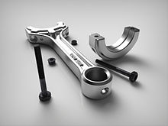](https://en.wikipedia.org/wiki/File:Piston2.14.jpg)

Fig no 3.2.1.12 example of modeling in CATIA

**3.2.1.13 Architecture:**

Architect [Frank Gehry](https://en.wikipedia.org/wiki/Frank_Gehry) has used the software through the C-Cubed Virtual Architecture company, now Virtual Build Team, to design his award-winning [curvilinear](https://en.wikipedia.org/wiki/Curvilinear) buildings. His technology arm, [Gehry Technologies](https://en.wikipedia.org/w/index.php?title=Gehry_Technologies&action=edit&redlink=1), has been developing software based on CATIA V5 named [Digital Project](https://en.wikipedia.org/wiki/Digital_Project). Digital Project competes for market share with Graphisoft's ARCHICAD, [Revit](https://en.wikipedia.org/wiki/Revit), [AECOsim Building Designer](https://en.wikipedia.org/wiki/AECOsim_Building_Designer) and other [Building Information Modelling](https://en.wikipedia.org/wiki/Building_Information_Modelling) applications. [Shop Architects](https://en.wikipedia.org/wiki/SHoP_Architects) company is using CATIA for its designs.

**3.3 Design procedure:**

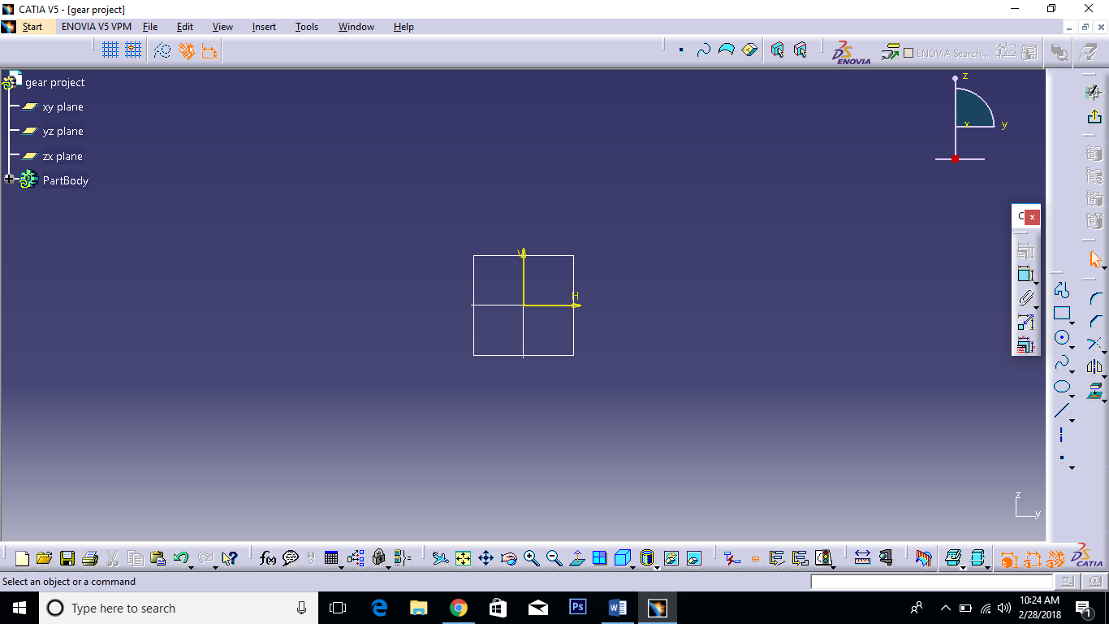1. CATIA software and go to start menu, click on mechanical design and select part design or sketcher.

Fig no 3.3.1. Creating part design

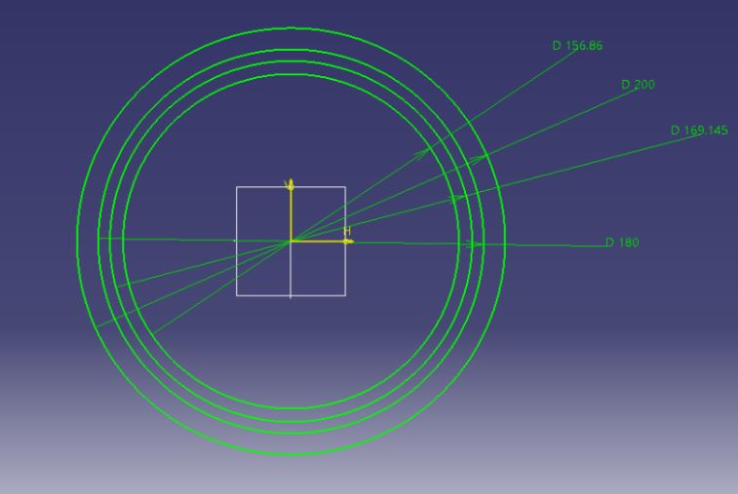2. Select a plane and select a center circle from profile tool bar, draw a four circles with dimensions.

Fig no 3.3.2 Drawing circles

3. Draw a reference (axis) lines from origin and set pressure angle 20 degrees and again draw straight axis line between two reference lines.

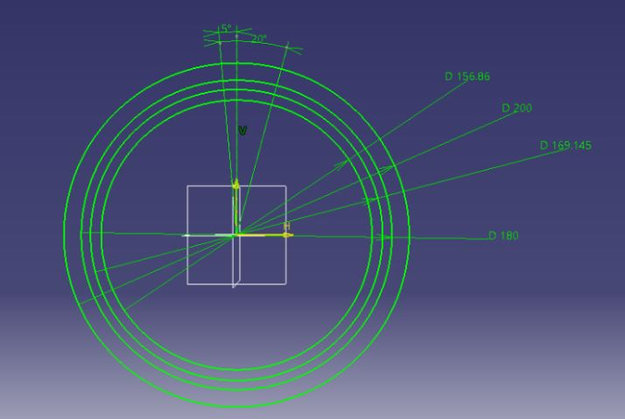Give an angle 5 degree center line to left axis line.

Fig no 3.3.3 Give pressure angle and dimensions

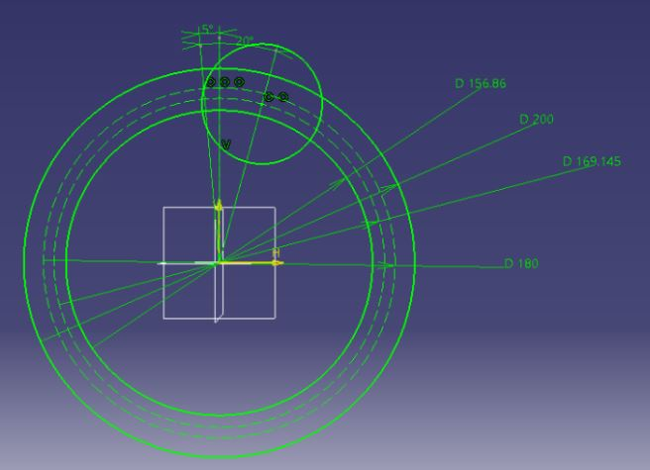4. Convert center two circles to construction lines. And draw a circle with contact of base circle and 3rd circle.

Fig no 3.3.4. Draw a circle for Gear tooth

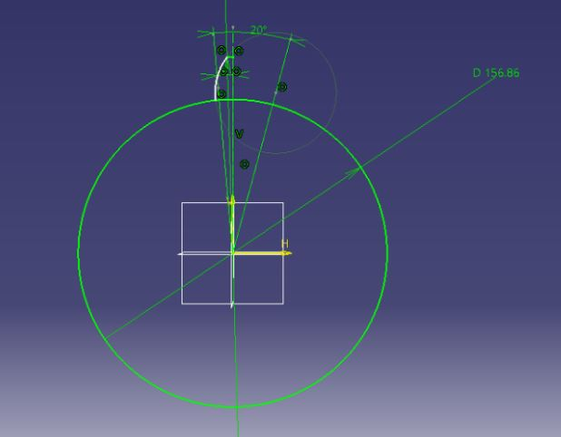5. Hide two construction lines and use trim tool, erase the unwanted circle lines to convert half tooth profile.

Fig no 3.3.5. Creating Gear tooth

1. 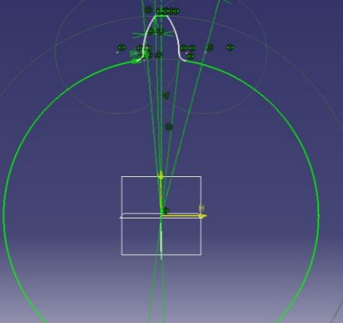Use the **mirror** command to complete tooth profile and give fillet radius with 3.5 mm, to make smooth tooth.

Fig no 3.3.6 Gear tooth

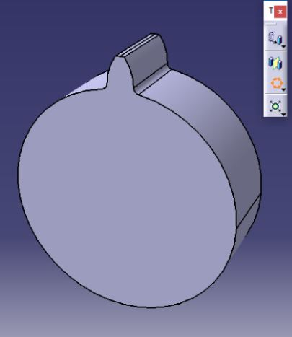7. Press **exit workbench** command and use **pad** command, give a thickness 54mm.

Fig no 3.3.7. 3D model Gear

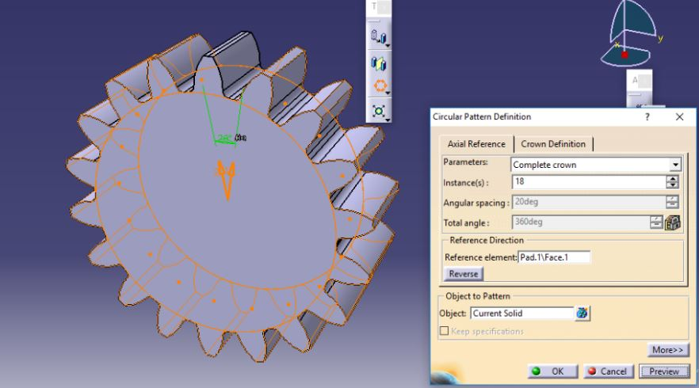8. Select a **circular pattern**, give the following parameters, instances, angular spacing and select circular face to form the complete gear profile.

Fig no 3.3.8. Gear pattern

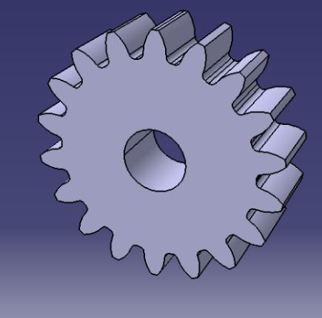9. Select a front face and draw a circle with 50mm. Use pocket command and make hole.

Fig no 3.3.9. Gear profile

1. 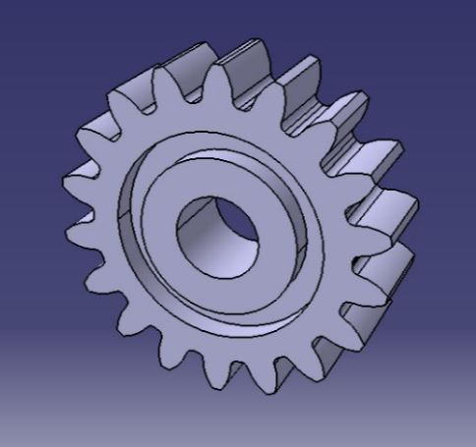To make complete gear profile like this.

Fig no 3.3.10. Gear profile

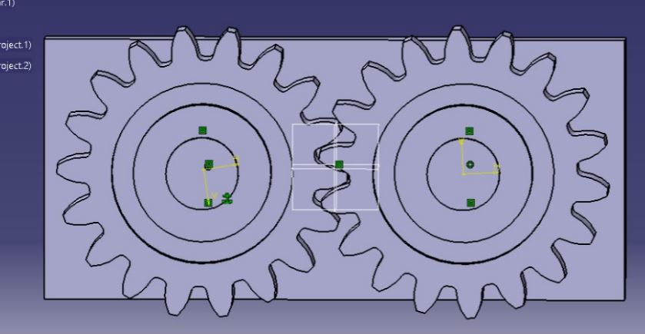11. To select assembly design, take gear profiles put side by side with help of plate.

Fig no 3.3.11. Assembly Design

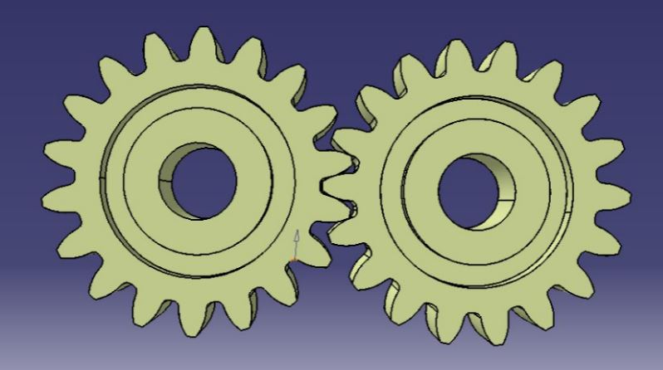12. Remove base plate and fixed constrain. And convert cat file to igs file.

Fig no 3.3.12. .igs file

Design and assembly process is completed.

**3.4 INTRODUCTION TO CATIA V5 DESIGN AUTOMATION**

CATIA V5 is a powerful tool in the CAO field. With some work you could be able to design almost everything. But how many times will we need, for example, to create ALL screws in our assembly? With each type? Each diameter? Hopefully a tool named VBA exists to get rid of this waste of time. CATIA overcome this by VBA Macros.

CATIA product which allows users to embed knowledge within design and leverage it to assist in engineering decisions, in order to reduce CATIA product which allows users to embed knowledge within design and leverage it to assist in engineering decisions, in order to reduce errors or automate design, for maximum productivity. CATIA product which allows users to embed knowledge within design and leverage it to assist in engineering decisions, in order to reduce errors or automate design, for maximum productivity.errors or automate design, for maximum productivity.

**3.4.1 Structure of CATIA Program:**

There are three major CATIA objects, namely Documents Part Document and Product Document. All the three CATIA objects are classes. But Part Document and Product Document are classes that obtain properties and methods from document class. Therefore, both Part Document and Product Document classes have in common methods and properties that are obtained from document classes and it also have own unique methods and properties. The specification tree has shown in figure 2 of apart document roughly correlates to underlying programmatic structure of the part object, but not exactly.

CATIA V5 can be piloted with mainly three possible languages:

1. Visual Basic 6

2. VBA

3. CAT Script

**3.4.1.1 VISUAL BASIC 6:**

VB Script (Visual Basic Script) is a subset of VBA. It is a simple interpreted Basic language

**3.4.1.1.1 ADVANTAGES:**

* Only Windows/Unix « compatible » language
* Can call CATIA Objects Directly
* Launchable from a saved macro.

**3.4.1.1.2 DISADVANTAGES:**

* Weak help to programming.
* Very ‘light’ internal editor No type is used.
* The system tries dynamically to call methods and properties of objects.
* And Sequential programming is Poor User Interface toolsin Visual Basic.

**3.4.1.2 VBA**:

VBA (Visual Basic for Applications) is a subset of Visual Basic. VBA is hosted in applications such as Word, Excel or CATIA.

**3.4.1.2.1 ADVANTAGES:**

* Programming help.
* « Event » Programming
* CATIA drive from another VBA application (Excel, Word …)
* Rich User Interface (buttons, lists, …)

**3.4.1.2.2 DISADVANTAGES:**

* Weak protection
* Not easy to export program
* No « Install Shield » too

**3.4.1.3 CAT SCRIPT**:

Visual Basic is the full version

**3.4.1.3.1 ADVANTAGES:**

* More extended set of instructions
* Code protection (compiled program)
* Can create ActiveX and Servers provides an added documentation called “Books on line” (VB 5.0) Packaging and deployment assistant

**3.4.1.3.2 DISADVANTAGES:**

* Needs an additional installation
* Microsoft licensed software

**3.4.2 INTRODUCTION TO MACRO:**

A **macro** is a series of functions, written in a scripting language, that you group in a single command to perform the requested task automatically, saving time and reducing the possibility of human error.

**3.4.2.1 Macro Libraries**:

The interface of the dialog “Tools + Macro + Macros…” allows to choose a library of macro (a directory of macro or a VBA project) or a document on which we wish to work. Macro Libraries the interface of the dialog “Tools + Macro + Macros…” allows to choose a library of macro (a directory of macro or a VBA project) or a document on which we wish to work.

**3.4.2.2 Recording a Macro**:

Recording a Macro generates a script corresponding to the creation or modification of the objects in the recorded sequence. After stopping the recording, we can store, edit or replay this script (called macro). The panel of recording VBA allows to choose the container in which we are going to record, the used language and the name of the macro to be recorded. The syntax of the recorded script is going to differ according to the menu chosen. As a rule, recording a macro helps to learn how to program something**.**

**3.4.3 DESIGN AUTOMATION OF SPUR GEAR:**

1. Open CATIA software and go to the “Tools” option then click on the “Macro”.

2. Click on the “Start Recording” option then it shows a dialogue Box.

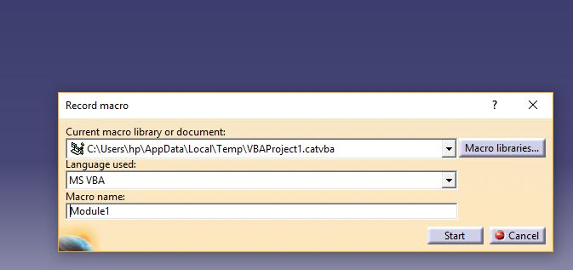3. Change the script of the CATIA from VB Script to CAT Script then click on OK option then CATIA starts recording the design in the form of CAT Script.

Fig no 3.4.3.1 Macro recording

4. Then Design the Spur Gear in CATIA and after completing the design save the design and click on the stop recording option on the dialogue box.

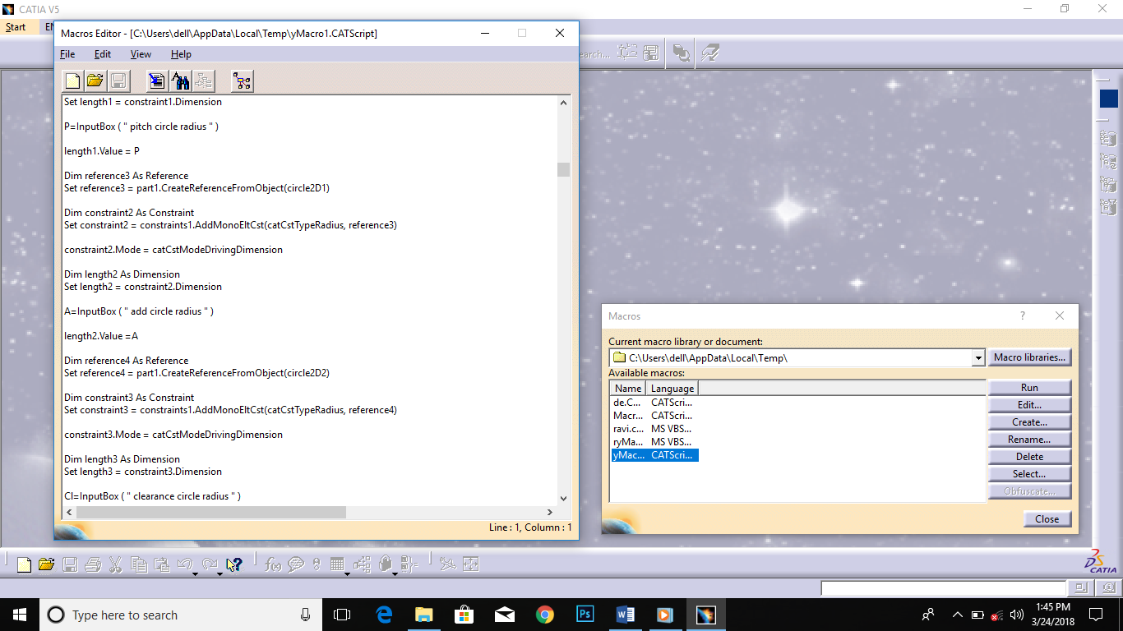5. Again go to the “Tools” option and click on the “Macro” and open “Macros” and Edit the macro recorded for Spur Gear by click on the “Edit” option.

Fig no 3.4.3.2 Cat script

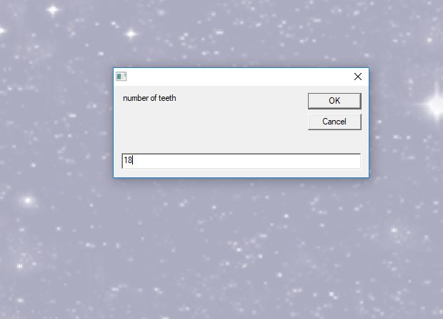6. We edit the CAT Script of Spur Gear in such a way that we automate the design parameters.

Fig no 3.4.3.3 Design Automation cat script

7. Save the edited Macro and Run the Macro enter the exact parameter values of the Spur Gear then it gives the Spur Gear design.

Fig no 3.4.3.4. Spur Gear

**CHAPTER 4**

**INTRODUCTION TO ANSYS**

**4.1 ANSYS**

ANSYS develops and markets [finite element analysis](https://en.wikipedia.org/wiki/Finite_element_analysis) software used to simulate engineering problems. The software creates simulated computer models of structures, electronics, or machine components to simulate strength, toughness, elasticity, temperature distribution, electromagnetism, fluid flow, and other attributes. Ansys is used to determine how a product will function with different specifications, without building test products or conducting crash tests. For example, Ansys software may simulate how a bridge will hold up after years of traffic, how to best process salmon in a cannery to reduce waste, or how to design a slide that uses less material without sacrificing safety.

Most Ansys simulations are performed using the Ansys Workbench software, which is one of the company's main products. Typically Ansys users break down larger structures into small components that are each modeled and tested individually. A user may start by defining the dimensions of an object, and then adding weight, pressure, temperature and other physical properties. Finally, the Ansys software simulates and analyzes movement, fatigue, fractures, fluid flow, temperature distribution, electromagnetic efficiency and other effects over time.

Ansys also develops software for data management and backup, academic research and teaching. Ansys software is sold on an annual subscription basis.

**Topics Include:**

1. Workbench GUI
2. Design Modeler
3. Overview of FEA
4. Engineering Data
5. Meshing
6. Parametric Modeling
7. Advanced Loads and Boundary Conditions
8. Assemblies
9. Multiple Load Steps
10. Coordinate Systems
11. Post processing
12. Intro to Thermal Analysis
13. Modal Analysis

Ansys develops and markets [finite element analysis](https://en.wikipedia.org/wiki/Finite_element_analysis) software used to simulate engineering problems. The software creates simulated computer models of structures, electronics, or machine components to simulate strength, toughness, elasticity, temperature distribution, electromagnetism, fluid flow, and other attributes. Ansys is used to determine how a product will function with different specifications, without building test products or conducting crash tests. For example, Ansys software may simulate how a bridge will hold up after years of traffic, how to best process salmon in a cannery to reduce waste, or how to design a slide that uses less material without sacrificing safety.

Ansys simulations are performed using the Ansys Workbench software, which is one of the company's main products. Typically Ansys users break down larger structures into small components that are each modeled and tested individually. A user may start by defining the dimensions of an object, and then adding weight, pressure, temperature and other physical properties. Finally, the Ansys software simulates and analyzes movement, fatigue, fractures, fluid flow, temperature distribution, electromagnetic efficiency and other effects over time.

Ansys also develops software for data management and backup, academic research and teaching. Ansys software is sold on an annual subscription basis.

**4.1.2 Applications:**

[:[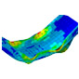](https://www.ansys.com/en-in/products/structures/composite-materials)](https://www.ansys.com/en-in/products/structures/composite-materials)

Fig no 4.1.2.1 Composite analysis

**4.1.2.1 Composites:**

The light, strong and versatile properties of composite materials make them attractive for many types of manufacturing. Composite materials like carbon fiber (CFRP), typically used in the aerospace and automotive sectors, are being used increasingly in other applications, such as bicycle frames and musical instruments. Their composite nature, however, makes accurate simulation a challenge.

[[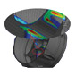](https://www.ansys.com/en-in/products/structures/durability)](https://www.ansys.com/en-in/products/structures/durability)

Fig no 4.1.2.2 Durability

**4.1.2.2 Durability**:

Building durable products is key to reducing warranty costs and increasing reliability. Being able to understand how designs will behave over time as load cycles increase helps you to avoid unexpected failures and warranty costs. Fatigue analysis is a key enabler in building this knowledge about product durability.

[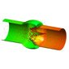](https://www.ansys.com/en-in/products/platform/multiphysics-simulation/fluid-structure-interaction)

Fig no 4.1.2.3 Fluid and structure interactions

**4.1.2.3 Fluid and structure interactions:**

ANSYS makes it easy to predict the interactions between fluids and structures, enabling engineers to optimize the behavior of complex products with the highest fidelity. Accurate simulation of the fluid–structure interface can enable your engineering team to dive deeper to get a better understanding of your product’s behavior. Interaction with structures is a critical computational fluid dynamics (CFD) app you have to get right.

Plastic cooling fans used in automotive thermal management and other applications save cost and weight but are prone fail due to deformation. New ANSYS Fluent-Mechanical system coupling accurately evaluates performance and durability. The structural simulation is performed on a stationary mesh (with Rotational Velocity) applied and the Fluids simulation is performed on a rotating mesh accounting for non-axisymmetric. This new capability also can be applied to other rotating machinery applications as diverse as helicopter rotors.

[](https://www.ansys.com/en-in/products/structures/impact)

Fig no 4.1.2.4 Impact

**4.1.2.4 Impact**:

Impact between two or more bodies is modeled by the ANSYS structural family of programs, including mechanical, explicit dynamics and rigid body dynamics. These programs calculate the forces between two or more colliding bodies and the resultant deformation or damage. Explicit Dynamics generally is used for high speed interactions or complex contact. RBD is suited for impacts with no deformation, or when deformation can be ignored.

[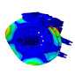](https://www.ansys.com/en-in/products/structures/optimization)

Fig no 4.1.2.5 Optimization

**4.1.2.5 Optimization**:

The first step in an analysis process is simulating the performance of a base design. Then you can re-use the model to investigate design parameters, different loading, changes in environmental conditions and variations in manufacturing. ANSYS Design Explorer enables you perform all your simulation in a single environment, ensuring the best design for any condition.

[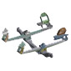](https://www.ansys.com/en-in/products/structures/rigid-body-dynamics)

Fig no 4.1.2.6 Rigid body dynamics

**4.1.2.6 Rigid body dynamics:**

Mechanical systems often contain complex assemblies of interconnected parts undergoing large overall motion: suspension assembles in ground vehicles, robotic manipulators in manufacturing processes and landing gear systems in aircraft, for example. Simulating the motion of these systems by assuming fully flexible parts and then deploying traditional finite elements methods for the solution is computationally expensive. For a faster, more efficient solution, the ANSYS Rigid Body Dynamics add-on module provides inexpensive, robust analysis of rigid multibody dynamics.

[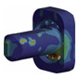](https://www.ansys.com/en-in/products/structures/strength-analysis)

Fig no 4.1.2.8 Strength

**4.1.2.8 Strength analysis:**

The strength of components is a key requirement in understanding a product’s performance, lifecycle and possible failure modes. Mechanical loading, thermal stress, bolt tension, pressure conditions and rotational acceleration are just some of the factors that will dictate strength requirements for materials and designs. ANSYS Mechanical ensures your product’s viability and safety by predicting the strength required for the loads your design will experience in service.

[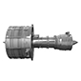](https://www.ansys.com/en-in/products/structures/thermal-analysis)

Fig no 4.1.2.9 Thermal

**4.1.2.9 Thermal** **analysis**:

The effects of heat and thermal management of structures is more and more critical as performance limits are pushed further by the need to have lighter, smaller and more efficient designs. Convection, radiation and conduction loads are obvious, but the need to include the effect of power losses and thermal energy from friction and external sources such as pipe flows means that analysts need to have more tools at their disposal to simulate thermal models accurately.

[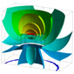](https://www.ansys.com/en-in/products/structures/vibrations)

Fig no 4.1.2.10Vibrations

**4.1.2.10 Vibrations**:

Vibration can be an undesired side effect of poor product design or the environment in which the product is operating. It can have a big impact on durability and fatigue, leading to a shorter service life. You need to understand how your designs will respond to vibrations from phenomena such as brake squeal, earthquakes, transport, and acoustic and harmonic loads to predict the behavior of products and components. ANSYS Mechanical simulations can provide this understanding and help you to overcome your toughest vibration challenges.

* 1. **ANALYSIS PROCEDURE OF SPUR GEAR**

**4.2.1 STATIC STRUCTURAL ANALYSIS OF COMPOSITE SPUR GEAR**

**CASE 1: - MATERIAL – SILOCON CARBIDE**

**Save CATIA model as .iges format**

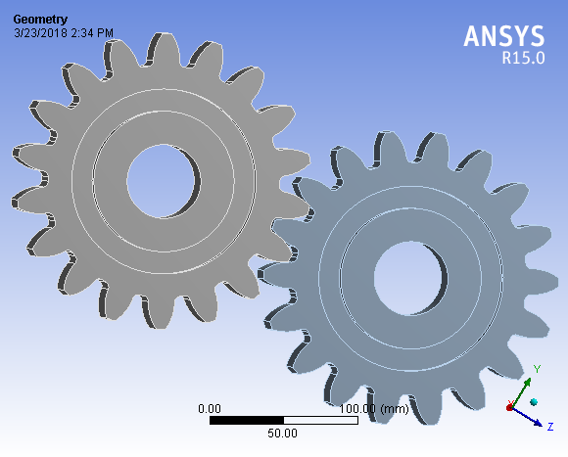**→→**Ansys → workbench → Select analysis system→ Static Structural → double click → → Select geometry → import geometry → select browse → Open Part→ Ok

Fig no 4.2.1.1.geomtry of Gear in Ansys

Double click on geometry→ select geometries → edit material→

**CASE 2:- MATERIAL PROPERTIES OF SILICON CARBIDE:**

Density : 3.15g/cm3

Young’s modulus : 250Mpa

Passions ratio : 0.3

→→select mesh on work bench → right click → edit

Select mesh on left side part tree→ right click→ generate mesh→

Fig no 4.2.1.2. Gear Meshing

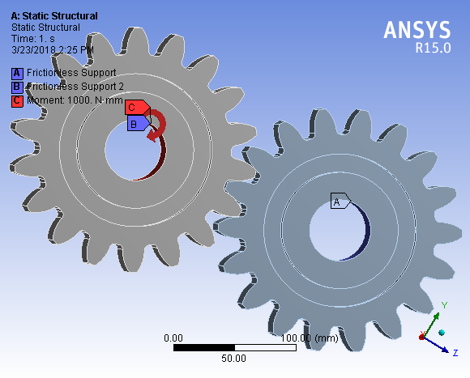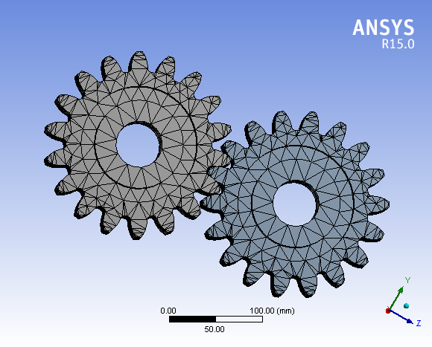Select static structural right click → insert → frictionless supports and moment – 1000 N-mm

Fig no 4.2.1.3. Appling loads on Gear

Select solution right click → solve →

Select right click → insert → Total Deformation → solution right click→ insert → strain →

Equivalent elastic strain → Solution right click → insert → stress→ Equivalent (von-mises) .

Select on Equivalent stress → click solve

TORQUE T = 138 N-m; SPEED = 2500 rpm

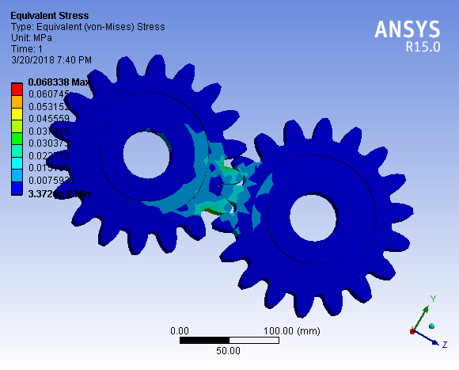**4.2.1.4 EQUIVALENT VON –MISES STRESS**

Fig no 4.2.1.4 Von-Mises Stress Distribution of Spur Gear in Silicon Carbide

The minimum stress value is 3.3724e-6 Mpa and Maximum value is 0.06833 Mpa

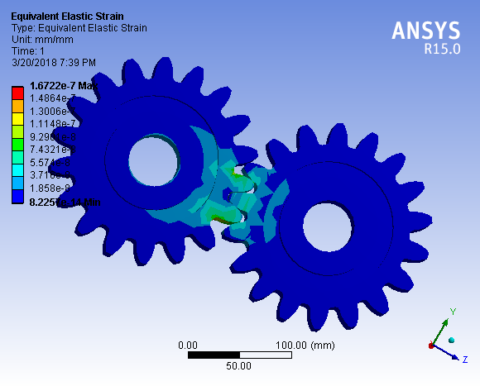**4.1.2.5 EQUIVALENT ELASTIC STRAIN**

Fig no 4.2.1.5. Equivalent elastic strain of Spur Gear in Silicon Carbide

The minimum strain value is 0.2254e-14 and Maximum value is 1.6722 e-7

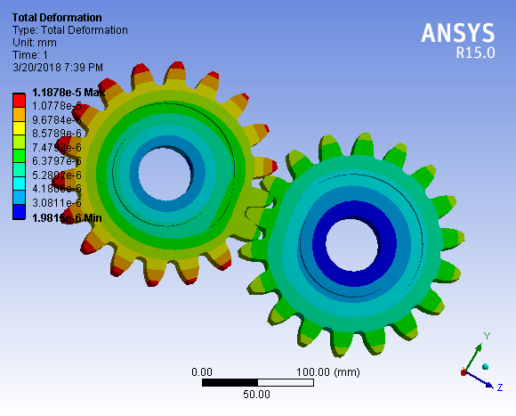**4.1.2.6 TOTAL DEFORMATION:**

Fig no 4.2.1.6. Total Deformation of Spur Gear in Silicon Carbide

Minimum value is 1.981e-6 mm and Maximum value 1.1871e-5 mm

**CASE 3:- MATERIAL PROPERTIES OF STRUCTURAL STEEL**

Density **:**

Young’s modulus :

Passions ratio :

TORQUE T = 138 N-m; SPEED = 2500 rpm

**4.1.2.7 EQUIVLENT VON-MISES STRESS**

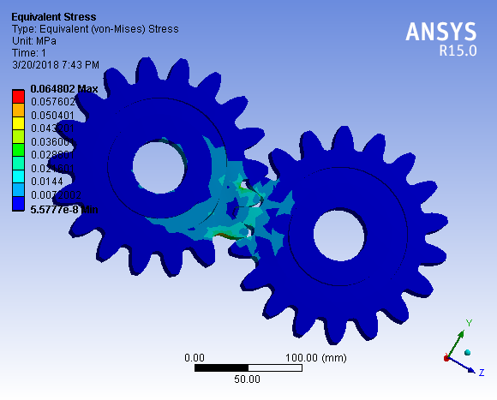

Fig no 4.1.2.7Von-Mises Stress Distribution of Spur Gear in Structural steel

Minimum value is 5.5777e-8Mpa and Maximum value is 0.064802 Mpa

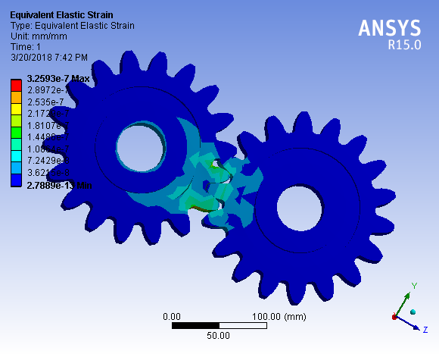**4.1.2.8 EQUIVALENT ELASTIC STRAIN:**

Fig no 4.1.2.8. Equivalent elastic strain of Spur Gear in structural Steel

Minimum value is 2.7889e-13  and maximum value is 3.259e-7

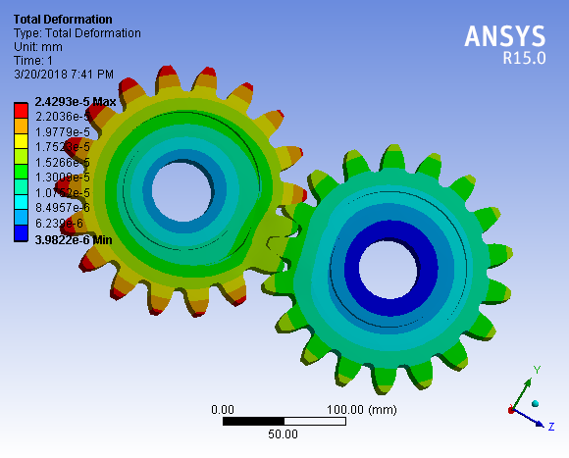**4.1.2.9 TOTAL DEFORMATION**

Fig no 4.2.1.9. Total deformation of Spur gear in structural steel

Minimum value is 3.9822e-6 mm and Maximum value is 2.4293e-5 mm

**CASE 4:- MATERIAL PROPERTIES OF TITANIUM**

Density :

Young’s modulus :

Passions ratio :

TORQUE T = 138 N-m; SPEED = 2500 rpm

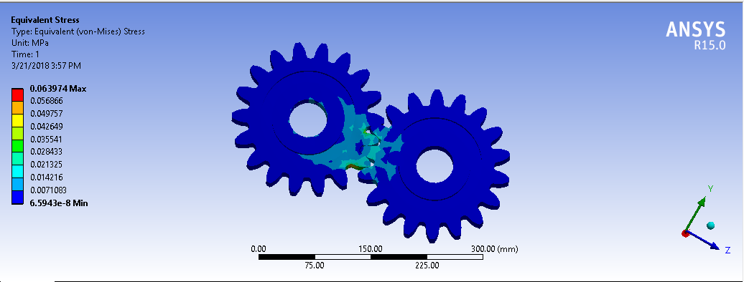**4.1.2.10 EQUIVALENT VON-MISES STRESS**

Fig no 4.2.1.10. Von-Mises Stress Distribution of Spur Gear in Titanium

Minimum value is 6.5943e-8 Mpa and Maximum value is 0.063974Mpa

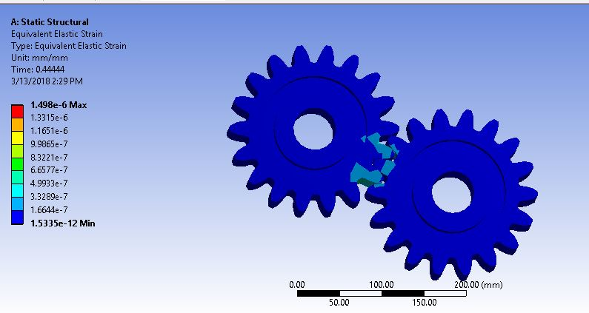**4.1.2.11 EQUIVALENT ELASTIC STRAIN:**

Fig no 4.2.1.11. Equivalent Elastic strain of Spur Gear in Titanium

Minimum value is 1.5335e-12  and Maximum value is 1.498e-6

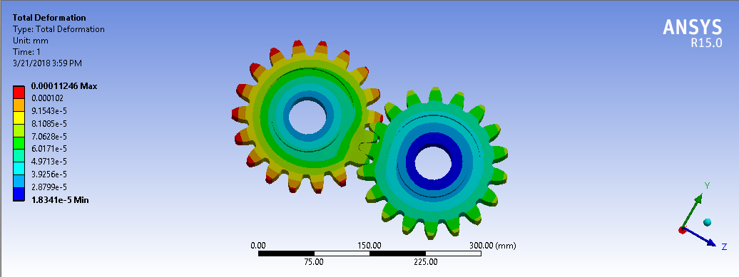**4.1.2.12 TOTAL DEFORMATION:**

Fig no 4.2.1.12. Total deformation of Spur Gear in Titanium

Minimum value is 1.18341e-5  mm and Maximum value is 0.00011246 mm

**CHAPTER – 5**

**RESULT AND DISCUSSIONS**

**5.1 Comparison Tables between Silicon Carbide, Structural Steel and Titanium:**

**5.1.1 Equivalent Von-Mises stress:**

**Table: 5.1.1**

|  |  |
| --- | --- |
| Materials | Equivalent voin-mises stress  (Mpa) |
| Silicon Carbide | 0.0683 |
| Structural Steel | 0.0648 |
| Titanium | 0.0639 |

**5.1.2quivalent Elastic strain:**

**Table: 5.1.2**

|  |  |
| --- | --- |
| Materials | Equivalent Elastic strain |
| Silicon Carbide | 1.6722e-7 |
| Structural Steel | 3.259e-7 |
| Titanium | 1.498e-6 |

**5.1.3 Total Deformation:**

**Table: 5.1.3**

|  |  |
| --- | --- |
| Materials | Total Deformation  (mm) |
| Silicon Carbide | 1.1878e-5 |
| Structural Steel | 2.4293e-5 |
| Titanium | 0.0001123 |

**5.2 Scope of project:**

Gears made from a rigid material such as metal or metal alloys are well known and are used in many applications. These gears withstand with high Torque load forces, but have a significant in that they generate a great Noise when they mesh with other metal gears.

Gears are made from titanium, Structural steel and Titanium materials are well known, and have been used to give high strength and less weight Generated by metal gears. The disadvantages in Titanium gears have High production cost, in which they cannot withstand at high Temperatures without damaging the gear teeth.

Gears are made from a composite material, it have been used to Made light weight gears compared metal gears. And also corrosion Resistance. Disadvantage of composite gears have high initial cost.

**CHAPTER – 6**

**CONCLUSIONS AND FUTURE WORK**

**6.1 Conclusion:**

The following conclusions can be drawn from the analysis conducted in this study.

It was concluded that the von-mises stress values are calculated for Silicon Carbide is approximately same as compared to the titanium, and Structural Steel but the von-mises stress of Silicon Carbide is slightly greater than the remaining two materials.

The equivalent strain for the Titanium Spur Gear is much better than Structural Steel and Silicon carbide.

The total deformation for the Titanium Spur gear is much better than Structural Steel and Silicon Carbide.

So from these analysis results, we conclude that, the stress induced, deformation and weight of the composite spur gear is less as compared to the Titanium spur gear.

**6.2 Future work:**

1. Various composite materials can be applied instead of currently used materials.
2. The input conditions can be varied to parameters like pressure, temperature etc.
3. A study on wear, friction and temperature effects can be extended.

**Objective of project:**

The objective of the project is to reduce the stress distribution, deformation and weight of spur gear by using Silicon carbide, Structural Steel, Titanium materials in the application of gear box.

The designed composite spur gear is compared with the existing gear materials, which are Silicon Carbide, Titanium, and Structural Steel.

The tool which is used to analyses the composite Spur Gear is ANSYS.

In this, the analyses of Deformation, strain and stress induced are to be performed for Silicon Carbide, Structural Steel and titanium materials.

The final outputs of these analyses for Silicon Carbide, structural Steel and Titanium materials are to be compared.

From this comparison, the stress induced, deformation and Strain for composite spur gear materials are to be less than that of the titanium spur gear materials.

**CHAPTER - 6**

**References**

1. V. Siva Prasad, Syed AltafHussain, V.Pandurangadu, K.PalaniKumar. Modeling and Analysis of Spur Gear for Sugarcane Juice Machine under Static Load Condition by Using FEA. International Journal of Modern Engineering Research (2012), 2(4):2862-2866.
2. S.Mahendran, K.M.Eazhil, L.Senthil Kumar [2012] carried out DESIGN AND ANALYSIS OF COMPOSITE SPUR GEAR. This project includes design of the spur gear to study the weight reduction and stress distribution for cast steel and composite materials under conditions using FEA mehod.
3. R.Yakut, H.Duzcukoglu, M.T.Demirci Mechanical Education Department, University of selcuk, Campus.
4. Mahebub Vohra, Prof. Kevin Vyas "Comparative Finite Element Analysis of Metallic and non-Metallic spur gear", May-June 2014, IOSR Journal of Mechanical and Civil Engineering, 11(3):136-145.
5. M.H. Tsai, Y.C. Tsai, ―A method for calculating static transmission errors of plastic spur gears using fem evaluation, Finite Elements in Analysis and Design‖ 27 (1997) 345-357.
6. S. Kirupasankar, C. Gurunathan, R. Gnanamoorthy. Transmission efficiency of polyamide nanocomposite spur gears‖, Indian Institute of Information Technology, Design and Manufacturing (IIITD&M) Kancheepuram, Melakottaiyur, Chennai 600 048, India, Materials and Design 39 (2012): 338-343.
7. K. Mao, ―A numerical method for polymer composite gear flash temperature prediction‖, Mechanical Engineering, School of Engineering and Design Brunel University, Uxbridge, Middlesex UB8 3PH, UK, accepted 8 January 2007.
8. M. KEERTHi, K. SANDYA, K. SRINIVAS “static and dynamic analysis of spur gear using different materials”, DVR & Dr .HS MIC college of technology, Andhra Pradesh, India.
9. R. Vigithra “DESIGN AND ANALYSIS OF NANO COMPOSITE SPUR GEAR” ARPN Journal of Engineering and Applied Sciences, Panimalar Institute of Engineering, India. Accepted June 2015.